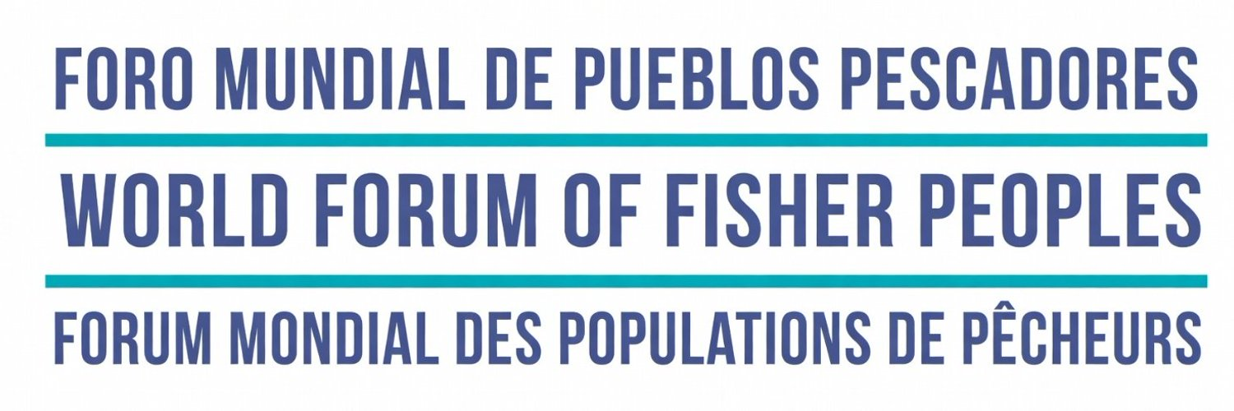

Living Manifesto of the Peoples of the Waters
Oceans, Seas, Mangroves, Reefs, Beaches, Bays, Lagoons, Lakes and Rivers
World Forum of Fisher Peoples (WFFP)
Continental Forum of the Americas and the Caribbean, 1–4 May 2026

We the peoples of the sea, mangrove, reefs, seagrass beds, platforms, beaches, bays, lagoons, lakes and rivers, we speak from our ecosystems and our living territories and amphibian territories.
From Georgetown, Guyana, by embracing the pulse of the Greater Caribbean and the Americas, we raise our voices alongside the Peoples of the Waters.

We who fish, gather, process and trade in artisanal and small-scale fisheries speak — defending the self-determination of our peoples: with our hands, with nets woven from history, with knowledge that fits on no page yet lives on in collective memory. Our peoples include women, Indigenous peoples, Black peoples, Cholos, Raizales, and the great diversity of artisanal fishing and gathering peoples, including those of inland waters, as well as youth and children.

Today we raise our voices, because we feel the pain of the oceans, seas, mangroves, lakes, rivers and the land.

They hurt from the industrial overfishing that decimates life.

They hurt from the environmental crimes that have displaced our peoples.

They hurt from the pollution that poisons the waters and our bodies.

They hurt from the dispossession of our living spaces, fishing grounds and fish migration routes: from the advance of an economic model built on extractive industries, intensive aquaculture (including shrimp, salmon, mariculture, and others), the mining and energy sector (both onshore and offshore, including wind energy), hydroelectric projects, hydrocarbons (oil, natural gas and plastics), port development, waterway infrastructure and industrial vessels, urban development and construction projects; monocultures; gentrification; industrial tourism; and exclusive conservation, like 30x30. As well as the appropriation of our ancestral knowledge.

They hurt from privatisation, evictions, dispossession, land grabbing, and criminal economies that displace our communities, destroy our ecosystems, and infiltrate our territories on both water and land.

They hurt from the climate crisis that threatens our peoples, territories, acuatorios and maritorios.

They hurt from policies that violate our rights, ignore us, displace us, criminalise us, prosecute us, and militarise our territories.

They hurt because the balance that we have tended across generations is being broken.

We feel the pain of that violence.

We express our deep concern and solidarity with the peoples of the world — especially with fishers, artisanal gatherers and riverside communities who today are being attacked, persecuted and killed in contexts of war and conflict, where rockets, bombs and drones destroy life and the fabric of community.

We demand unrestricted respect for the human and collective rights of our peoples.

We denounce a geopolitical context that advances in the privatisation, militarisation and the criminalisation in the use and defense of our ecosystems, territories, maritorios and acuatorios.

We also denounce the policies of the so-called Blue Economy and Blue Transformation, which, under a discourse of sustainability, deepens the commodification of nature, promotes new forms of land grabbing and privatisation of our territories and common goods, and excludes the peoples who have historically cared for them.

In the Americas and the Greater Caribbean, fisher peoples, artisanal gatherers and riverside communities are not the problem: we are part of the solution.

We are guardians of biodiversity, stewards of life in the water.

We know when to fish, when to gather and when to wait.

We know that the sea, the mangrove, the rivers and the lagoons are not commodities: they are territories, maritime spaces, aquatic territories and inland waters; they are ecosystems, they are wetlands, they are culture, histories, stories, legends, food and spirituality.

Therefore we strongly assert:

To fight for the recognition of our territories and ecosystems as our living spaces.

To demand the recognition of our autonomy, of the co-management and active, binding participation in the governance of our territories. Thinking globally to act locally with the commitment to continue building and securing that another world be possible.

To halt their destruction, contamination, criminalisation and the displacement of our peoples.

And so we say it plainly:

We do not accept models that destroy in the name of progress.

We do not accept decisions made without the participation of our peoples.

We do not accept being made invisible in the policies that affect our lives.

We propose and demand:

The full recognition of our customary rights and our customary and traditional rights and our own regulatory systems, collective, territorial and of traditional of in the coasts, bays, beaches, mangroves, reefs, wetlands, inland waters and reservoirs.

Real, direct and binding participation in the management and governance of marine and coastal territories and common goods.

The strengthening of our local, solidarity-based and community economies, grounded in artisanal fishing and gathering. Our horizon is food sovereignty above food security, guaranteeing healthy, fresh and fair food through our practices of aqua-ecology.

A native fishery, free from grafted, introduced or invasive species.

Effective protection of ecosystems — that includes us, instead of excluding us.

The immediate halt of activities that pollute (directly and also through the movement of the waters) and destroy our ecosystems, our territories and waters, our bodies, food and our ways of life.

We demand to be included in environmental monitoring processes and in compensation and redress processes when our ways of life, territories, maritorios, and acuatorios are destroyed.

The promotion, through our organisations, of the construction of community codes of conduct for the responsible stewardship of our living spaces.

We mobilise the implementation and the strengthening of the Small-Scale Fisheries Guidelines as a genuine tool for the defence of our rights and the conservation of our territories, maritime spaces and aquatic territories.

We demand that our governments implement the Small-Scale Fisheries Guidelines and assume them as state policy. Likewise, we demand that we be made an integral part of popular agrarian reform processes and that fulfillment is given to the United Nations Declaration for the Rights of Peasants and Other Peoples that Work in Rural Zones (UNDROP) and to the Declaration of the United Nations for the Rights of the Indigenous Peoples (UNDRIP).

We demand climate finance directed to our organisations and peoples.

We are committed to the Nyéléni Forum process and we join the internationalist solidarity work that seeks systemic transformation — now and immediately.

We support the global Forum's campaign against intensive aquaculture and the advocacy work of the Peoples’ Tribunals of the Oceans and Waters.

We further commit to deepening — through our World Forum and through the strengthening of our national and regional organisations — the active participation and political formation of young people, women, Indigenous peoples, inland fishers, and girls and boys in our political and organisational debates, as a guarantee of both present and future.

We recognise the role of women as central to our communities, acknowledging their labour and their leadership across all organisational processes and in the stewardship of all our spaces.

We believe in collective solutions:
in community organisation, in shared care, in the transmission of knowledge between generations, in joy as a political force that resists and builds.

Because we are still here.

Because we continue to reproduce life in the water.

Because we are not the past: we are the present and the future.

From Georgetown, Guyana — rooted in our beautiful and bountiful fishing and gathering living spaces, and connected with the peoples of the Greater Caribbean and the Americas — we affirm:

To defend marine and riverside ecosystems, territories, maritime spaces and aquatic territories is to defend life.

We promote aqua-ecological practices to achieve food sovereignty and to build our own narratives and practices through the political formation of our movement, including our youth and women.

And life is not up for negotiation.

Signed by the organisations present at this Continental Forum of the Americas and the Caribbean.

May 2026.

