**Historical Importance of Fisher Peoples and**

**the Support System for Food Sovereignty on Planet Earth**

Out of the 4,000 odd habitable planets so far identified by astronomers, this is the only planet that has a water cycle as far as we know. As nature’s way of water recycling, large amounts of water recycled daily, and the process takes place as evaporation, condensation, precipitation and collection, stored as clouds which in turn rain down to us as recycled water. This continuous system take up different states as liquid (water), gas (vapour) or solid (ice). It is then collected by oceans, and rivers and the water cycle repeats itself over and over again! This cycling process means that freshwater is constantly made available to Earth's surface where we all live. If not for this, life cannot exist on this planet.

Nearly 71 percent of the Earth's surface is covered with water, and all the oceans hold about 96.5 percent of Earth's water. Large amounts of water is found at the two ice caps in the North Pole and the South Pole where three-quarters of Earth’s fresh water frozen and stored as glaciers. Additionally, volcanoes release massive amounts of water from the inner Earth to the atmosphere. Consequently, water is made available to us through mountain springs, water falls, rivers, lakes, canals, streams and ponds. People also draw ground water from wells. Fresh water is used for drinking, cooking, bathing, cleaning, washing clothes and for agriculture.

Since the creation of this Earth and the gradual formation of salt water and fresh water bodies, nature has ensured an abundance of both salt water fish and fresh water fish varieties supporting especially human life. Humanity would not have survived this long if not for the abundance of fish nature has provided. Our ancestors who lived in coastal regions just went out to the sea, caught fish and used for food. Similarly, those who lived in the country’s interior caught fresh water fish and that is how their families survived before the invention of agriculture.

Eventually, these fisher folk who later became sea farers and ventured into travel long distances finding new prospects, developed trade. Understanding the importance of conserving and protecting all water bodies on this planet to ensure the future survival of all living beings, trees, vines, plants, flora and fauna that sustain the livelihood of both fisher and farming communities is vital.

At the 8th General Assembly of the World Forum of Fisher Peoples (13 – 22 November 2024) in Brasilia, Brazil, one of the main themes discussed was climate change effects on fishing communities in the world. Members of WFFP from many parts of the globe shared lived realities. The fisher peoples of the world, especially SSF are on the front line of the climate crisis and exposed to extreme weather conditions. Among the issues identified that require urgent action and collective political resolve were :

1. Forms and drivers of Ocean Grabbing
2. Climate crisis
3. Pressing challenges faced by communities striving to secure food sovereignty.

Food Sovereignty focused on the pressing challenges as many nations struggle with corporate-driven agricultural systems, and the session explored the complexities of resisting industrial agriculture, protecting local food systems, and ensuring that food remains accessible, culturally appropriate, and sustainably produced. Organizations such as the LVC, FIMARC, FIAN International, FoE and WMW that networks with other social movements engaged in the food sovereignty process, collaborates with WFFP in advocacy campaigns and political processes to safeguard the rights of peasants, SSF and other food producers globally. The principles of Food Sovereignty are intertwined with the UN SSF guidelines. WFFP engages with the food sovereignty movements since the first Nyelini conference held in Selingue, Mali in February 2007, to learn, internalize and to practice the agro-ecology as their tools for the struggle for better aquatic resources management and utilization of resources in a sustainable manner.

As per the Nyelini Declaration, we are fighting for a world where;

* all peoples, nations and states are able to determine their own food producing systems and policies that provide every one of us with good quality, adequate, affordable, healthy, and culturally appropriate food;
* recognition and respect of women’s roles and rights in food production, and representation of women in all decision making bodies;
* all peoples in each of our countries are able to live with dignity, earn a living wage for their labour and have the opportunity to remain in their homes;
* where food sovereignty is considered a basic human right, recognised and implemented by communities, peoples, states and international bodies;
* we are able to conserve and rehabilitate rural environments, fish stocks, landscapes and food traditions based on ecologically sustainable management of land, soils, water, seas, seeds, livestock and other biodiversity;
* we value, recognize and respect our diversity of traditional knowledge, food, language and culture, and the way we organise and express ourselves;
* there is genuine and integral agrarian reform that guarantees peasants full rights to land, defends and recovers the territories of indigenous peoples, ensures fishing communities’ access and control over their fishing areas and eco-systems, honours access and control over pastoral lands and migratory routes, assures decent jobs with fair remuneration and labour rights for all, and a future for young people in the countryside;
* where agrarian reform revitalises inter-dependence between producers and consumers, ensures community survival, social and economic justice and ecological sustainability, and respect for local autonomy and governance with equal rights for women and men…where it guarantees the right to territory and self-determination for our peoples;
* where we share our lands and territories peacefully and fairly among our peoples, be we peasants, indigenous peoples, artisanal fishers, pastoralists, or others;
* in the case of natural and human-created disasters and conflict-recovery situations, food sovereignty acts as a kind of “insurance” that strengthens local recovery efforts and mitigates negative impacts… where we remember that affected communities are not helpless, and where strong local organization for self-help is the key to recovery;
* where peoples’ power to make decisions about their material, natural and spiritual heritage are defended;
* where all peoples have the right to defend their territories from the actions of transnational corporations.

Most of us food producers are ready, able and willing to feed all the world’s peoples, as our heritage as food producers, is critical to the future of humanity.

Considering the present situation in the world with so many challenges and threats to SSF and all other food producers, the WFFP is highly concerned whether if this increasing trend continues, it is possible that the world will face a food shortage soon. This includes the spiralling grabbing of oceans and land, dwindling access to land and resources are among the major ways in which impoverished communities are all disenfranchised. Overall, the dismantling of territorial rights has a devastating impact on the sovereignty and self-determination of peoples. The multiple different but interconnected crises impacting us all, in different regions of the world and across all our sectors, show that there is an urgent need for transformative systemic change.

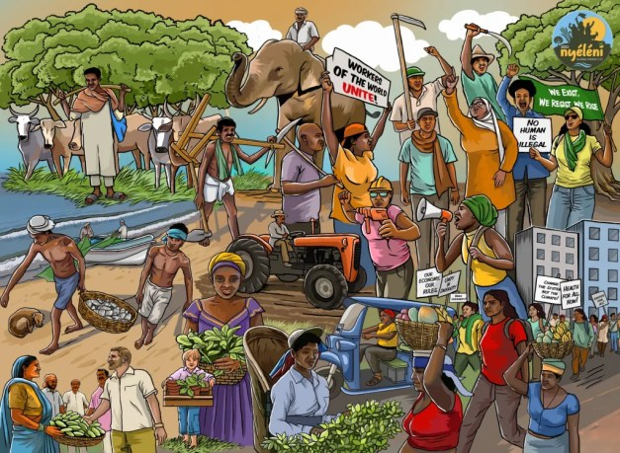WFFP networking with organizations and social movements engaged in the food sovereignty process, is promoting advocacy campaigns and political processes to safeguard the rights of food producers globally. As part of this process, the WFFP in coordination with the international and local steering committees of the 3rd Nyelini Forum is working to organize this event which is scheduled to be held in Kandy, Sri Lanka in September 2025. Fishing communities and other food producers worldwide are invited to join hands to contribute to the success of this initiative. This event is expected to gather more than 500 participants from around the world, engaged in food sovereignty, the defense of the commons, the right to health, climate justice, feminism, social and solidarity economies, agroecology, and Indigenous knowledge, Nyéléni aims to spark a global paradigm shift in response to today’s economic, political, social, and environmental crises.

**Freddie Jayawardena**

**Manager, Program Design and Fund Raising, WFFP**