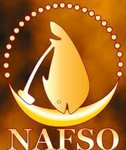
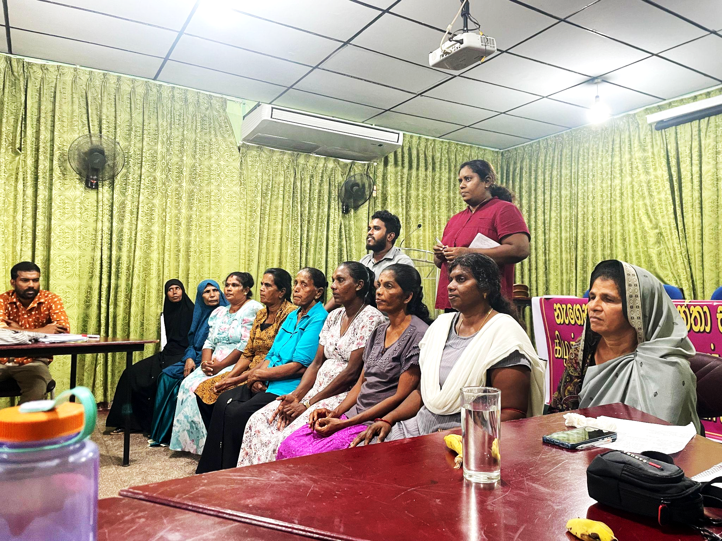
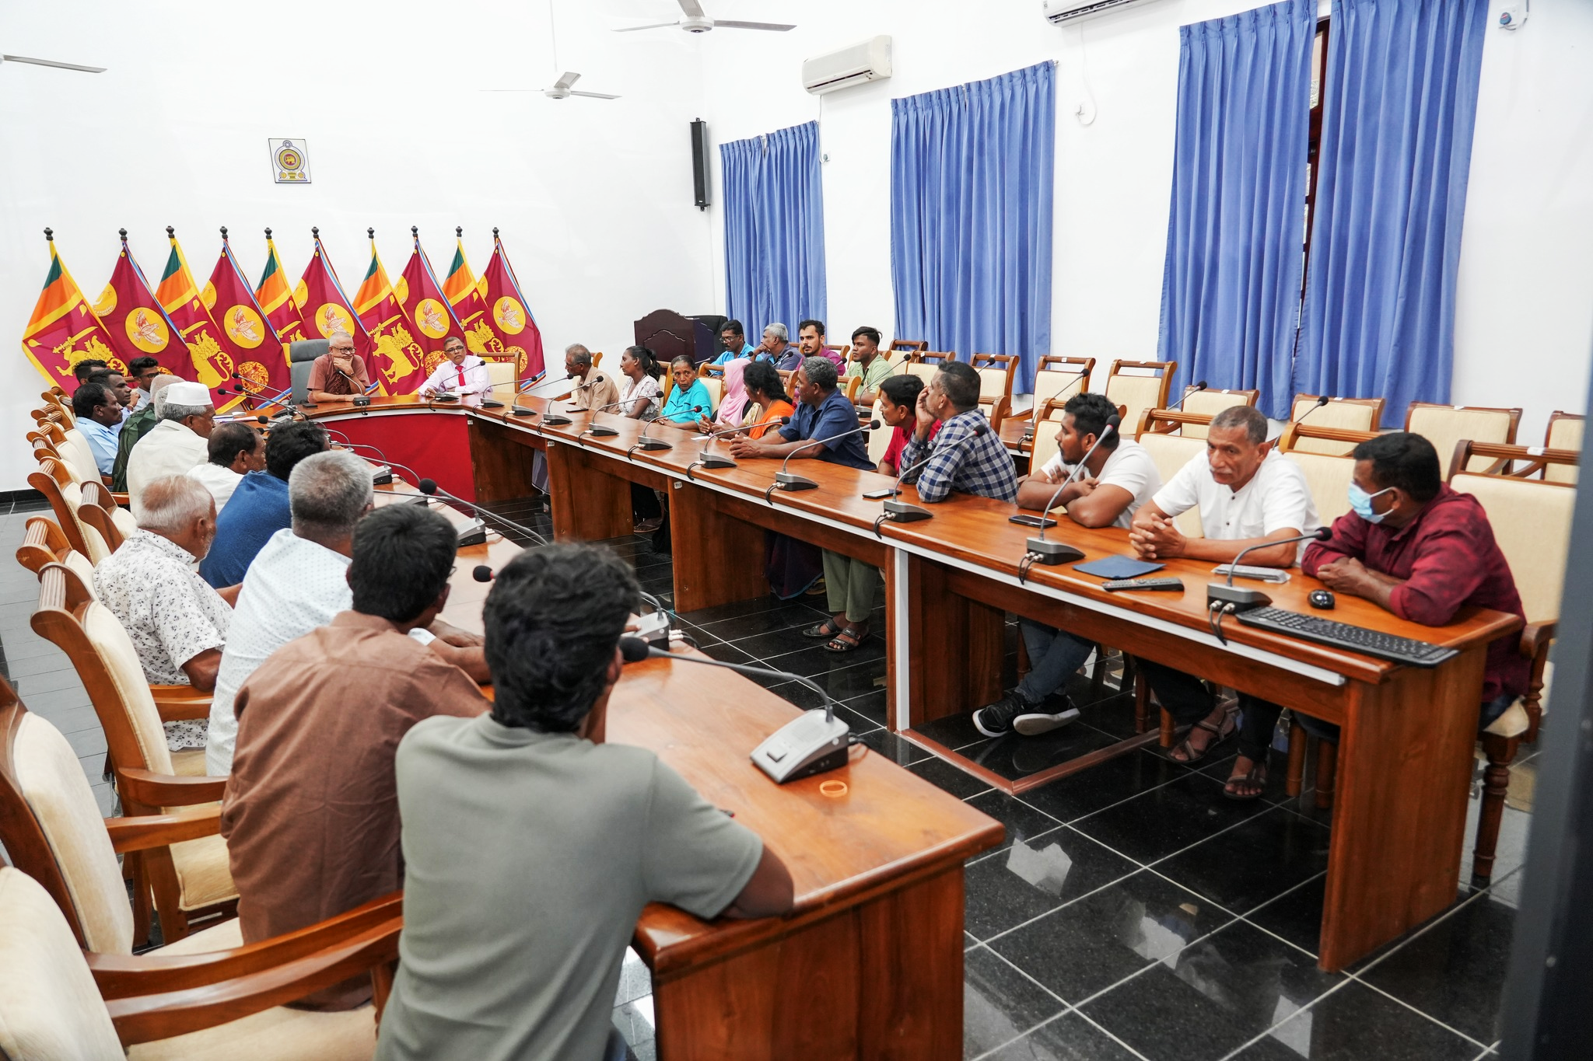

01-16-2025

Fisherwomen in the Eastern Province

NAFSO facilitated meetings with fisherwomen of the Eastern Province to discuss their common struggles and how they are working as a community to overcome them.
Sri Lanka is a patriarchal society whereby women, especially women-headed households, face intersectional challenges due to traditional gender roles, such as difficulties generating income, contributing to community decision-making, accessing social protection mechanisms, and attaining their rights to association and unionization. Fisherwomen in the Eastern province, through the support of NAFSO, have organized themselves in community bodies to increase their awareness of societal dynamics and their rights, thereby empowering themselves to work towards addressing their concerns.
Generating income
Women farmers and fisherwomen contribute more than 50% to the food production process, on top of substantial household responsibilities. However, women reportedly earn 50 LKR less per hour than their male counterparts and their rights to access land, low-interest credit, water, capital, and equipment are often denied as men typically own fishing boats and hold land titles. As a result, women-headed households face significant challenges and most married fisherwomen are economically dependent on their husbands. Lack of economic independence, entrenched in and reinforced by patriarchal views, means that women’s opinions are not often heard within or outside of the household. Increased economic stress among families can disproportionately harm women as patriarchal attitudes reinforce men’s control of household finances and contribute to domestic violence.
Additionally, social and cultural norms – such as excluding women from certain production activities or high alcohol consumption and drug misuse in fishing communities – reduce opportunities for women and subject them to workplace harassment and domestic abuse. Through the NAFSO Eastern Province Women’s Federation, women raised alcohol and drug misuse as a top priority to bring to the National Women’s Federation which was convened in Negombo on January 17-19, 2025.
As women seek to generate income and acquire independence, some are pushed into relying on large-scale industrial fishing enterprises. Large-scale industrial fishing is increasing in Sri Lanka and supported by politicians, largely due to personal interest or investment in these businesses and a desire to use neoliberal practices to decrease national debt. However, this further widens the gap between rich and poor, and negatively impacts ecosystems and traditional livelihoods. Small-scale fisherfolk are struggling at large, meaning women face heightened challenges as they seek to obtain market access for their products and acquire living wages as workers in the fishing industry.
Women in the Eastern province discussed a number of alternative income generating opportunities for themselves, such as facilitating village-level training on skills like stitching, dry fish, and making traditional food, soap, lotion, and other goods, which could then feed into a weekly district market to sell their products. This would become a platform for women to share traditional knowledge with one another and learn new skills from other professionals. It would also provide an opportunity for women to directly market their products with buyers, ensuring fair prices and reducing reliance on middlemen. Ongoing work within these federations will focus on identifying resources and solutions to garner support from other bodies, such as the Government of Sri Lanka, other NGOs, and international bodies. Support from these groups through financial or technical assistance could open opportunities to acquire seed funding or business management training, expand marketing contacts, create networking platforms for women to market their products directly at the local and international level, and advocate for income-related rights.
Decision-making and rights to association, unionization, and social protection
Social norms entrenched in contemporary laws and a lack of implementation of laws in support of women hinder women’s inclusion in key fisheries management, cooperatives, and government discussions, thereby weakening their bargaining power to call for gender-sensitive policies in the sector. Even when women are granted membership to fisheries cooperatives, their opportunities to assume leadership roles are often denied. Additionally, low female education among poverty-affected families means many women do not know their rights and have little means to organize themselves and apply pressure for change.
However, through the NAFSO Village, District, Province, and National Women’s Federations, women actively participate in local decision-making processes and provide a gendered lens to wider small-scale fishery concerns. Through these federations, 8,000 women have become members of NAFSO, thereby magnifying their voices on a national and international scale.
Nonetheless, women’s inclusion in government-recognized village fisherfolk societies remain hindered. A practical consequence felt by women in the Eastern province is that without membership in these organizations, they are also unable to access social security schemes or insurance programs. In order for this to change, the Government of Sri Lanka must first change the fishing act to recognize women and workers, not just boat owners, to allow women to become members of these societies. In order to apply organized pressure, women in the Eastern Province have requested support in acquiring awareness training on their rights at a level where women of low education statuses can learn how to advocate for change. A national policy which supports the inclusion of women would meet practical needs through financial support, education, and access to resources while also increasing their recognition as leaders within the fishing sector and the drafting of policies which are gender-sensitive.

About NAFSO
NAFSO, established in 1997, works with and for small scale fisherfolk communities. The main focus areas of work include small-scale fisheries, women and youth empowerment, harmony and reconciliation, environmental protection, food sovereignty, and land rights. This is primarily done through community organizing, advocacy and lobbying, training, and the provision of resources.

