Report

on the

Socio Economic Political and Ecological implications of

Blue Economy on the coastal communities

[Year]

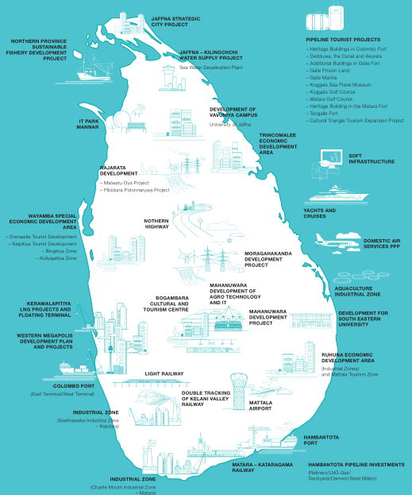

# CONTEXT / BACKGROUND

The importance of the coasts and the oceans to human life is undisputable. Humans have inhabited the coasts for millennia, with several coastal communities around the world having a deep sense of history and intimate cultural relationship with the coasts and oceans. These resources are vital for our livelihood, nutrition and overall health of our planet mother earth.

Of late, the concept of “Blue Economy” as a growth model, pushed by leading global organisations and international financial institutions, has been adopted by the nation-states across the world using ocean eco-system and coastal eco-system to promote economic growth. The blue economy has diverse components, including established traditional ocean industries such as fisheries, tourism, and maritime transport, but also new and emerging activities, such as offshore renewable energy, aquaculture, seabed extractive activities, and marine biotechnology and bio-prospecting (World Bank, 2017).

However, the concepts of “Blue Economy” are hardly new, but a mere continuation of existing paradigms of exploitative development of the last several decades using coastal and marine resources. For instance, productivity enhancing fisheries based on destructive technology have been promoted the world over. Massive and unplanned industrialization and infrastructure development along the coasts like ill-sited ports, highly polluting factories, power plants, rampant sand mining, tourism projects, roadways and artificial waterways and destructive forms of aquaculture have been steadily growing the world over, and enjoying policy and institutional support globally.

**The major human impacts include, among others, the following**

* Unplanned and Unregulated development, Mining and Deforestation in the narrow coastal interface and near shore areas has led to significant externalities between sectors, overlapping uses of land and marine areas, marginalization of coastal communities, physical alterations of landscapes and destruction of marine and coastal habitats, loss or degradation of critical habitats, massive erosion and siltation causing disasters
* Climate Change, caused by human industrial and infrastructure activity has led to sea-level rise and more intense and frequent weather events - changes in sea temperature, ocean acidification, and major oceanic currents threaten marine life, habitats, reefs, and the communities that depend on them.
* Marine Pollution, in the form of industrial effluents, untreated sewerage, agricultural runoff, and marine debris such as plastics (An estimated 8 million tons of plastic enter the oceans each year (Jambeck, 2015) resulting in loss of bio diversity, destruction of fish stock and loss of livelihood resources dependent on them.
* In Coastal Zones, declines in mangrove forest habitat resulting from habitat conversion wood harvest, destruction of dune systems from sand mining, and changes in sediment and pollutant loading from river basins combined with land reclamation for agriculture or infrastructure have serious negative impacts on fisheries by reducing or degrading spawning and feeding habitats.
* Experts say the annual value of marine and coastal ecosystem services will progressively decline over the next 25 years, from today’s value of just under USD 52 billion to a value of USD 30 billion by 2039. This pattern of decreasing ecosystem service values is repeated across all of the Bay of Bengal countries (BOBLME, 2014).

In a nutshell, the challenges can be summed up as:

Coastal and Marine ecosystems have been viewed and treated as limitless resources and largely cost-free repositories of wealth and waste disposal. The narrow coastal interface is oversubscribed by myriad sectors whose externalities and unintended consequences have not been adequately addressed.

Ineffective governance, institutions, usurpation of traditional rights of the coastal communities, lack of implementation of SSF guidelines, UNCLOS and other legal instruments, and insufficient application of sustainable management tools have often led to excessive use and, in some cases, irreversible change of valuable marine resources and coastal areas.

Concerns to be addressed

Determining what constitutes the blue economy is a challenge in itself, with different stakeholders, nation-states and international organisations adopting this growth model as per their convenience.

Before exploring concepts like Blue Economy, we first need to understand the extent of depletion of the coastal and marine resources. The environmental and natural resource assessments still need to be developed in a systematic way. Estimating Blue Economy must include economic activities, ecosystem services and social implications in the assessment.

It is imperative to use a common framework to develop a system to assess the blue economy, starting with the ocean usage and its contribution to national wealth, implications on the livelihoods of the coastal communities and ecosystem services that are not accounted for in the GDP. It is crucial to obtain global policy support to institutionalize such a framework. These policies must be based on the principles of polluter pays, precautionary principle and sustainable development. The Blue Economy assessment should be incorporated in national economic measures.

The knowledge on the structure of the current ocean economy and status of the coastal and marine ecosystems would be helpful to see how external events, such as storms, climate change and environmental changes may impact the blue economy development.

A regular regional reporting system on the State of Oceans and Coasts (SOC), with the ocean economy-environment assessments will measure the progress towards blue economy, including the benefits, gaps, and lessons learned.

# OUR INITIATIVE

In the above context, SNEHA is undertaking a study to document the implications of ‘Blue Economy’ supported by nation state, international bodies and armed with an array of researchers. Economists and experts.

**Objectives of the Study:**

* To enable the process of evolving an alternate ecosystem (network of systems) of policies, institutions, people centric jurisprudence at the regional level for the cause of coastal communities with a special focus on small scale fisherfolk and women, by generating knowledge from a people centric perspective
* To promote a platform for the voice of the Global South, which seeks to challenge the dominant discourse of development that has not only failed to respond to needs of the people, but resulted in loss of right over resources and loss of livelihood of coastal communities and large-scale damage to the coastal and ocean resources

**Methods and methodology followed**

Methodology is a blueprint to strategize a research systematically. As an outcome of the workshop, the Working Committee jointly accepted the conceptual framework in order to study the blue economy through the perspective of fishing communities, especially the traditional fisherfolk. The proposed study aims to *explore the “****Social, Economic, Ecological, Political Dimensions of Blue Economy****”* will explore and analyze the existing development agendas on coast and ocean with regard to specific coastal nations in South and Southeast Asia. The research adopts qualitative tools for data collection. The research primarily aims to look into the implications on the Capture fisheries and its allied activities with regard to Blue economy. Similarly, the research will also explore the implications of other blue economy components on Capture and Culture Fisheries.

# UNIVERSE OF THE STUDY

The universe of the study would be the fisherfolk population in the coastal states of India, Pakistan, Sri Lanka, Indonesia, Thailand and Bangladesh.

The respondents will be the *Primary Interest Groups*: ***Capture Fisheries***: Small-Scale Fishers, Mechanized Fishers, Fish Vendors, Prawn/ Crab Collectors, Indigenous Fishers, Net Menders women Vendors, Loaders, **Culture fisheries,**  Dry Fish Merchants, Fish Middle Agents, Aquaculture Farmers, Aquaculture merchants and other Interest groups who will influence Fisher Sangams, Fisher Cooperatives, Local Boat Builders, Traditional Panchayats, Regional Councils, NGOs/CSOs, Research Organizations, Government Departments, Policy Think-Tanks.

# SAMPLING SIZE

Sampling is a technique used in research to select the samples for the investigation. Samples are a select group of people of the universe population. The research will explore 3-5 Case studies for each coastal state to understand the impacts of other components of the blue economy on Capture and Culture Fisheries.

We are using purposive sampling method which we will select in close consultation with our local research collaborators.

# TOOL FOR DATA COLLECTION

Primary and Secondary data collections are essential components for research. To begin with, the proposed research will analyze the secondary data. Based on the analysis of secondary data, the research team will set the ground for primary data collection. This process will be the facilitated by the regional partners

Both data collection method and analysis were explained in brief.

**Primary Data**

The qualitative information will be conducted among selective respondents directly through guideline format and interview schedules if necessary. Three basic types of data collection methods will be utilized to collect data, namely: Observation; Interviews and Focus Group Discussion. The collaborating partner will facilitate process of collecting primary data.

**Secondary Data**

The secondary data will be sourced through various indirect and direct sources. The regional collaborating partners will help the research to gather the relevant information with regard to blue economy. The secondary source document will include, policies, acts, census data on fisheries. budget documents, world bank project documents, research articles, books, reports, newspapers clips and other relevant documents of the research.

**Socio Economic Political and Ecological Implications of Blue Economy on the Coastal Communities in Sri Lanka**

## **PROFILE OF SRILANKA**

Sri Lanka, an island with a sea area which is seven times larger than its land area of approximately 65,610 km2 and a coastline of length 1,620 km. in the Indian Ocean southwest of the Bay of Bengal, between latitudes 5° and 10°N, and Longitudes 79° and 82°E. Sri Lanka is the 57th most populated nation in the world, with. roughly 21,670,000 people. Sinhalese constitute 74.8%, Sri Lankan Tamils with 11.2%. Sri Lankan Moors comprise 9.2%. and the rest from Burghers (of mixed European descent) Malays and a small population of Vedda, the original indigenous group to inhabit the island.

Sri Lanka is a democratic republic and a unitary state which is governed by a semi-presidential system, with a mixture of a presidential system and a parliamentary system. Most provisions of the constitution can be amended by a two-thirds majority in parliament. The amendment of certain basic features such as the clauses on language, religion, and reference to Sri Lanka as a unitary state require both a two-thirds majority and approval in a nationwide referendum.

**Status of marine and coastal ecosystem**

The island consists mostly of flat to rolling coastal plains, with mountains rising only in the south-central part. The highest point is [Pidurutalagala](https://en.wikipedia.org/wiki/Pidurutalagala" \o "Pidurutalagala), reaching 2,524 metres (8,281 ft) above sea level.Sri Lanka's coastline is 1,585 km long. Sri Lanka claims an [Exclusive Economic Zone](https://en.wikipedia.org/wiki/Exclusive_Economic_Zone) (EEZ) extending 200 [nautical miles](https://en.wikipedia.org/wiki/Nautical_mile).

**Physical features**

There are three grades of altitude in Sri Lanka – the hill country (500-2,500 m above sea level), the mid-country, with elevations from 75 to 500 m above sea level and the lowlands (0-75 m above sea level). The climate of Sri Lanka is tropical and warm. Sri Lanka has two monsoons — the south-west monsoon and the north-east monsoon. Squalls and tropical cyclones occur in the country. The mean temperature ranges from 17°C in the Central Highlands to a maximum of approximately 33°C in other low-altitude areas.

Sri Lanka has 103 rivers – the longest of which is the Mahaweli (335 km). The coastline is surrounded by highly productive marine ecosystems (e.g. fringing coral reefs 65 Marine and Coastal Protected Areas in the South Asian Sub-region (Review Paper: Status of Coastal and Marine Ecosystem Management in South Asia and seagrass meadows). Sri Lanka also has 45 estuaries and 40 lagoons, as well as mangroves, which serve to protect the coast from natural disasters (e.g. the Indian Ocean tsunami of 2004). The island is rich in minerals such s [ilmenite](https://en.wikipedia.org/wiki/Ilmenite), [feldspar](https://en.wikipedia.org/wiki/Feldspar), [graphite](https://en.wikipedia.org/wiki/Graphite), [silica](https://en.wikipedia.org/wiki/Silica), [kaolin](https://en.wikipedia.org/wiki/Kaolin), [mica](https://en.wikipedia.org/wiki/Mica) and [thorium](https://en.wikipedia.org/wiki/Thorium). Existence of petroleum and gas in the [Gulf of Mannar](https://en.wikipedia.org/wiki/Gulf_of_Mannar) has also been confirmed and the extraction of recoverable quantities is underway

***Biological Riches***

Sri Lanka’s coastal habitats are diverse and include estuaries, lagoons, mangroves, seagrass meadows, salt marshes, coral reefs, barrier beaches, spits and dunes. Coral reefs cover an area of approximately 68,000 ha around the country, with the most extensive reefs being in the Gulf of Mannar. The coastal biodiversity of the country is extremely rich with 85 fish species including 51 fresh water crab species, The biodiversity of the coastal and marine ecosystems is meeting over 65 percent of the animal protein requirement of the country.

Marine and coastal protected areas

There are 30 marine and coastal protected areas in Sri Lanka, including national parks, sanctuaries, marine protected areas (MPAs), Special Area Management (SAM) sites and fishery-managed areas (FMAs), as well as marine components of terrestrial protected areas. There are also a number of de facto no-take zones (in the north and east of the country, as well as in Colombo Harbour).

Sri Lanka ecosystems and ecosystem services are threatened by climate change..The coast is vulnerable to the effects of rising sea levels which are likely to result in losses of land and coastal biodiversity as well as to increases in the frequency and strength of tropical storms associated with climate change leading to the loss of resources, employment opportunities and ecosystem services. The fisheries industry is also likely to be impacted by rising sea temperatures and ocean acidification, which will result in the destruction of coral reefs and loss of habitats important for a number of commercially important species

**Profile of Fisheries Sector**

Sri Lanka has an abundant fishery with territorial seas of 21,500 sq.kms and an Exclusive Economic Zone of 517,000 sq.km. Marine fisheries in Sri Lanka has a clear distinction between the north parts (Tamil) and the south, west (Sinhala) parts of the island nation.

***Fishing communities***

There are at least 1 337 fishing villages in the marine sector, with 1 289 in the inland sector, a total of at least 2 626 villages considered to derive their main income from fisheries. This implies about 132 600 households in marine fishing villages and 11 920 households in inland fishing villages, a total of about 144 520 fishing households for the country as a whole. The marine sector accounts for 85 percent of the employment in the fisheries sector. About 250 000 people are actively engaged in fishing in the marine, inland and aquaculture sectors, and another 100 000 persons are believed to be indirectly employed in fisheries, especially in marketing and other ancillary services.

***Traditional Fishery***

Traditional fishing also known as Artisan fishing is any kind of small-scale, low-technology, commercial or subsistence fishing practices, particularly those of coastal or island ethnic groups using traditional techniques such as rod and tackle, arrows and harpoons, throw nets and drag nets, and traditional fishing boats. Artisan fishing contrasts with large-scale modern commercial fishing practices in that it is often, but not always, less intensive and less stressful on fish populations than modern industrial fishing. Most of the species taken are associated with coral reefs, although oceanic and pelagic species are important and the coastal zone is far more important in artisanal fishing than the exclusive economic zone.

### ***Fishing production means***

The marine fishing fleet consists mainly of small- to medium-sized craft, owned and operated by private individuals and broadly classifiable into: non-motorized traditional craft, motorized traditional craft, fibreglass hulled boats of 6–7 m LOA;larger boats of about 3.5, offshore multi-day boats; and beach seine craft.

Traditionally, fishing has been inshore using simple canoes with outriggers and, despite development efforts spanning over 50 years, this type of boat made up nearly half of the fleets till 2004.

**Northern Sri Lanka:**

In the North, the fleets are almost entirely small scale including motorised as well as non-motorised. However, a few 1500 mechanised trawlers are also found in the north. These are all daily trip fishers. There is hardly any multi-day fishing conducted by northern fishers here. The north has a long tradition al fishing by everal traditional fishing communities like Karaiyar, Muthurayar, etc. Till 1950, fishing used to be with traditional cotton nets. The North had a thriving fishing economy. For instance, pre-1983, north contributed 43% of Sri Lanka’s total fisheries value. However, with the start of the civil war from 1983 onwards, fishing became extremely difficult till 2002 the 2004 tsunami devastated these coasts and destroyed whatever little was left of the fishing sector.

Since 2009 onwards, with the end of the civil war, there has been a slow and gradual recovery, with the north now contributing close to 17% of Sri Lanka’s Fisheries Economy.

### **The South:**

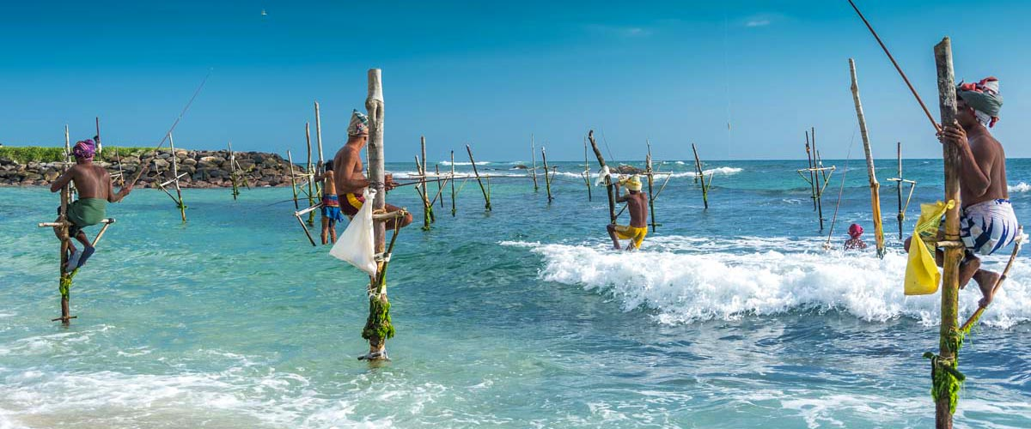

Stilt fishing sites in southern coast; namely Ahangama, Delwelangala, Hatapalana, Maradawala, Midigama and Weligama. Traditional stilt fishing industry is mainly based in Galle and Matara districts in southern Sri Lanka. Ahangama, Delwelangala, Hatapalana, Maradawala, Midigama and Weligama are traditional fishing villages situated at about 130 kilometers down south from the capital Colombo, Sri Lanka. The people of the area are Sinhalese and their religion is Buddhism. Culture and lifestyle are altogether different from other people engaged in fishing industry living in coastal areas of the country.

The south and west has a much more capital intensive mechanised fleet of gillnetters and tuna longliners. These southern fleets can be subdivided into two – first are those who making week long trips all around Sri Lankan waters, including in northern and eastern waters, and second those who fish for months at a stretch in the high seas all over the Indian Ocean. Some of them go as far as Yemen and the Red Sea. These are operated by the traditional fishing community of the south, called the Karava who seem to have carved a niche for themselves in deepsea fisheries.

In the 1950s, kattumarams and beach sienes were the predominant fishing practices used. Outboard engines were introduced in the 60s along with longer plank canoes. Norweigian support led to introduction of trawlers. However, unlike India, trawlers did not become popular. Instead, Japanese introduced fibre boats began to get popularised. These Karava fishermen innovated by making separate compartments for ice in those same boats, and these began to be called Tank Boats, which were fit for multiday fishing. These boats have since evolved into larger boats, with long-lines and gillnets, equipped with GPS, high frequency radios, and the like.

The fish landings centers are concentrated in the southern and western districts. As part of post war fisheries development programmes, there is a move towards harbour based mechanised fishing.

### ***Fisheries Resources***

### About 610 species of coastal fish have been reported from Sri Lankan waters, of which the more common species caught are small pelagic species which account for about 40 percent of the coastal fish catch. Though there no comprehensive resource studies available for offshore and deep-sea areas, about 90 species of oceanic pelagic species of fish have been reported from Sri Lankan offshore and deep-sea waters.  Moreover, it has been reported that about 60 species of sharks live in the oceanic waters off Sri Lanka. About 215 demersal species have been reported from the oceanic waters around Sri Lanka. Some surveys have indicated that surface tuna schools are available in areas offshore from the west, south and east coasts, with higher concentrations of fish within the 60 to 70 km range from the shore. Skipjack and yellowfin tuna have dominated the catches. Preliminary results of some trial fishing have indicated an abundance of sub-surface tuna resources within Sri Lanka's EEZ. (FAO2015)

The GOSL vision for post disaster development [Tsunami & War] along the coast

* In 2005, when Asian tsunami hit SL coasts, the GOSL proposed 15 Tourism zones in coastal areas. -100 M/200 M coastal buffer zones
* Make Sri Lanka one of the most popular holiday destinations in Asia- “Wonders in Asia”
* 2010 GOSL has proposed to establish a total of 45 “tourism zones” to develop tourism after war ended in 2009.

**INLAND SUB-SECTOR**

Sri Lanka has 103 perennial rivers, of which 23 river basins are larger than 500 km2. Of the total area of about 280 000 ha of inland water bodies, 160 000 ha are lakes and ponds, while the rest (120 000 ha) consists of lagoons and marshlands. Inland reservoirs and tanks usually carry water all the year round (70 000 ha) and other reservoirs and tanks (76 000 ha) are seasonal.

Indigenous species like Labeo dissoumeari and Puntius sarana are found in inland fish catches, introduced fish species, such as tilapias (Oreochromis mossambicus and O. niloticus) dominates inland fish landings. Attempts have also been made to introduce Indian and Chinese carp species into reservoirs.

Brackish-water resources are situated in the coastal belt in the form of estuaries, lagoons or marshes. They amount to 120 000 ha, of which some 80 000 ha are deep lagoons and estuaries. The rest are shallow lagoons, tidal flats, mangrove swamps and saline marshes.

***Aquaculture sub-sector***

Brackish-water aquaculture in Sri Lanka is completely dominated by shrimp farming. The major species cultivated is Penaeus monodon.  Industrial shrimp farming was mainly found in the northwestern provinces, where there were about 1 200 shrimp farms.According to FAO report 2006about 11 000 ha wereavailable for land-based coastal aquaculture, other than shrimp.

**Emergence of Blue Green Economy in Sri Lanka**

Srilankan Government has adopted the concept of BE at the ideological level during the Abudhabi convention held in 2012.

Abu Dhabi convention The Head Government and high-level representatives, having met in Abu Dhabi, United Arab Emirates, from 19 to 20 January 2014with the participation of civil society, discussed

* how to utilise and implement the Blue Economy as a tool to enable the transition of development models for island and coastal States towards sustainable development.
* It was viewed that the Blue Economy, founded in line with the concept and principles of, and mutually supportive with the Green Economy, is a tool that offers specific mechanisms for Small Island Developing States (SIDS) and coastal countries to address their sustainable development challenges.
* Recognising the significant contribution that the Blue Economy can make towards the alleviation of hunger, poverty eradication, creation of sustainable livelihoods and mitigation of climate change.
* Cognisant of the fundamental importance of the marine environment and its resources to future, inclusive sustainable development – inter alia:
* Fisheries and their vital role in providing food security and sustainable livelihoods,
* Tourism as a source of decent employment and a contributor to poverty alleviation,
* As a source of renewable energy from wind, wave, tidal, thermal and biomass sources.
* As a source of hydrocarbon and mineral resources.
* As the primary medium of global trade through shipping and port facilities.

Aware and greatly concerned that the oceans of the world are threatened and being seriously degraded by unsustainable exploitation, pollution, habitat destruction and acidification and being determined to address these threats.

* Welcoming the report of the Regional Preparatory Meeting of Small Island Developing States of the Atlantic Indian Ocean, Mediterranean and South China Seas held in Seychelles from 17-19 July 2013.
* Welcoming the report of the Nairobi Convention Regional Workshop on: Contributions of Natural Blue Capital to a Green Economy, held in Seychelles 11-13 December 2013.
* Recognising that States should take efforts to enhance management mechanisms that minimise and mitigate unsustainable exploitation of marine resources.
* Recognising that for many States transition to a Blue Economy will entail a fundamental, systemic change in policy, legal and governance frameworks.
* Noting that enabling mechanisms for the Blue Economy include technology transfer, capacity building, targeted streamlined financing mechanisms, including debt for nature and/or adaptation swaps, and modes of science-based implementation.

***Policy perspectives on Blue Green Economy*:**

Sri Lanka Next', a landmark campaign to take Sri Lanka towards the BlueGreen era, was formally initiated on 6th January 2016 under the aegis of President MaithripalaSirisena.He addressed people as the co-owners and appealed to them to work with the government in achieving the vision of Sri Lanka under Blue green economy growth model.The document on Blue green economy shared through the speech of President is summarized as follows

***Green Economy***

i. **Srilanka will establish clean industries engaged in low carbon emission production:** The government will embrace the new emerging green manufacturing opportunities that would position Sri Lanka as the world’s leading Green Manufacturing Hub that can demand a premium for its exports.

**Sri Lanka will create a watershed restorative, health preserving, organic agriculture for food security**:  
Food security and sustainability should be ensured by utilizing ecofriendly means for the development of agriculture.

iii. Sri Lanka will champion renewable energy generation, low loss transmission and energy storage utility sector

The premium quality graphite deposits that can be been converted to graphene to produce high capacity power storage battery devices, places Sri Lanka at a distinct advantage to become a global leader in the centralized or distributed electric power sector. Wind, Solar, OTEC, Thorium, Wave, and Hydro provides a multitude of options for Sri Lankans to become energy generating entrepreneurs and graphene-based power storage device manufacturers.

iv. **Sri Lanka will**  **create a green LEED standard construction industry**:  
to encourage all stakeholders in the construction industry to utilize environment friendly means and uphold the internationally recognized LEED standards

v. Sri Lanka will create an alternative energy

Public & private transport sector to encourage the use of alternative energy powered vehicles like electric, compressed air, and flex-fuel hybrid vehicles.

vi. Sri Lanka will create Green Cities and Villages that are healthy and safe to live:

Developers should be encouraged to utilize environment friendly standards for the construction of green cities and villages.

vii.Sri Lanka will **prepare for a Blue Green economy workforce**: In creating employment opportunities for future generations, attention should be paid to developing both the tertiary and secondary school system to equip students with the knowledge and expertise relevant for employment in a blue-green economy, and the curriculum expanded to include the new blue-green sectors of the economy, including the specializations that our children must now be encouraged to pursue. Our citizens who have gone overseas have been exposed to many of these blue-green economy opportunities, and many are leading practitioners in their respective fields that develop renewable energy, and other related green technologies, and encouraging them to return back home to take charge of this new emerging blue-green economy would be a priority.

***Blue Economy***

**i. Unlocking the value of our Ocean’s living resources sustainably:** Efforts should be made to utilize these resources employing sustainable strategies that would separate vulnerable areas as living marine resources protected sanctuary areas, and rotate the fishing areas around our island to give global leadership in sustainable fisheries management practices empowered with technology and best practices  Declaration of such fish habitat protection zones and marine practices would enable Sri Lanka to tap conservation funds.

**ii. Research our biodiversity rich marine biological resources to discover new medicines and products:** Sri Lanka’s marine region consists of valuable scientific study resources including corals and other marine life and priority should be given to encourage research and development of these resources for pharmaceutical & other valuable product catalyst discoveries  
i**ii. Tapping the potential of our ocean mineral & seabed resources to establish high technology “clean industries” that serves the global market**

Sri Lanka’s coast line, its environment and the ocean floor contain valuable mineral resources which can be converted to high value added products and services, which would open up a new “clean ocean industry” development opportunity for Sri Lanka. . Our universities and research led private sector and state sector must take the lead to unlock the vast potential jointly with cutting edge knowledge institutions from around the world

**iv. Establishing low carbon footprint port facilities:**Economic prosperity could be achieved by making Sri Lanka a hub for not just container trans-shipment, but also a natural gas storage hub, regional logistics management hub, ship building hub, oil & gas exploration rig building hub, regional seismic survey ship deployment hub, and even leisure cruise liners and private yachting berthing hub. All our modern sea ports must deploy energy conservation and pollution free practices to be certified as an eco-friendly berthing facilities to become global leaders in green port management.  
 **v. Developing a conservation oriented tourism industry that takes advantage of our renewable energy resources in the coast and the oceans.**

 Encourage the development of a green coastal tourism industry that champions the use of renewable energy from coastal and ocean energy sources and engage in coastal conservation and marine resource protection practices. Also source food supplies from local area organic farmers to minimize the transport carbon footprint, and engage in rain water harvesting, recycling and good waste management practices.  
  
**vii. Promoting coastal recreational, beach and water Sport activities:**To bring Sri Lanka to a prominent position as an island that excels in Olympic events like yachting, sailing, swimming, diving, and other internationally popular oceanic and beach sports like surfing, water skiing, beach volleyball, and other recreational water activities utilizing the natural lagoon, river and bay area habitat in our coastal areas.  
  
**viii. Openening up maritime archaeology and anthropology**:  
Historically, for centuries, Sri Lanka was a centre of a popular sea route and the numerous related activities contributed to a rich maritime archaeology need to be fully explored for academic pursuits and also recreational diving that has an important tourism industry attraction value.

**ix. Making Sri Lanka the guardian of the Indian ocean:**Sri Lanka is an important centre in the global geo political map in view of its relationship with international sea routes as well as being located at the center of an ocean biodiversity and climate change hot spot. Hence, several economic benefits could be obtained by turning attention to the sphere of protection of the ocean, both in assuring the freedom of the sea lanes by keeping the navigation channels free of piracy and military blockades, and also the prevention of climate change inducing pollution from waste oil discharges and ballast from vessels, and other hazardous waste materials that negatively impact on ocean life

This also includes our own responsibility to ensure our industries do not discharge untreated waste to the rivers that empty to the ocean around us. Waste generated sea algae blooms and ocean acidification contribute towards global warming. The task of monitoring these events by satellites and having the response capability with the correct intervention capacity and the allied services and deployment assets will be a priority investment for our nation.  
  
x**. Pursuing new global opportunities in ocean energy:**  
Due to its richness in oceanic resources, many areas of renewable energy could be identified. Feasibility of generating energy using sea waves and offshore wind power and OTEC (Oceanic Thermal Energy Conversion) needs to be identified and developed. Sri Lanka can become a low carbon, 100% renewable energy nation, comfortably achieving our emissions reduction pledge to keep global warming at 1.5 degrees, if we fully exploit our ocean energy resources and develop high capacity energy storage by developing technologically advanced batteries using our graphene resources and the ingenuity of human resource capital.

**xi. Developing coastal area protection measures and upgrade our coastal area habitat infrastructure to overcome sea level rise and climate change coastal erosion :**The vast areas of our coast is protected by natural sea erosion barriers like mangroves, which are valuable carbon sinks, and increasing that natural capital would enable Sri Lanka to tap international conservation funds. Furthermore, the upgrading of our coastal habitat infrastructure to be resilient to climate change impacts requires a total revamp of road elevations, storm water drainage systems, protection of vital power and telecommunication networks, and the overall design of urban, suburban and rural habitat areas that are vulnerable to coastal erosion and sea level rise. Protection of drinking water river intakes from salinity contamination and well water contamination needs to be considered to make our island climate change ready. This requires vast investments and also manpower mobilization to study the threats and design and develop solutions. This defensive investment will also boost the economy and assure our nation of less disruptions to our economy when climate change impacts the whole world.

**NATIONAL PHYSICAL PLAN 2013-2030**

The National Physical Plan provides the infra structure facilities to cater to the needs of Tourism & Industrial development.-SEZ and making SriLanka a Smart Nation

Under the Megapolis development program there will be 5 strategic cities such as Jaffna, Trincomalee, Kandy, Galle and Hambantota as well as establishment of new ministerial portfolio for the Megapolis ministry. Mega city project of Trincomalee started In October 2016. As a result of the project more than 3200 families from 13 villages will be displaced and dispossessed of their land, coast and livelihoods. On the other hand cabinet, has approved 15,000 acres of coastal land to lease out to the Chinese company from adjacent to Hambanthota harbour.

Development of Industrial cities and mega cities are planned such as Port city in Colombo, and air city in Negombo areas where fishing communities affect their livelihoods

***Tourism Development “Collaterals”***

Research with STP in 2015 :In Kankesanthurai [KKS] the military is running the Thalsevana Holiday Resort and only soldiers are working in the hotel. The local community does not gain any benefits of the Thalsevana Holiday Resort.

* Around 10,000 fishers in Kalpitiya islands affected by Tourism development
* In Kalkudah (Passikudah) the fishermen have lost almost all access to the sea.
* In Kuchchaveli the local community has not been informed about the implementation of the tourism zone

List of military – run tourist facilities and packages

|  |  |
| --- | --- |
| Army | * Laya Hotels (Laya Beach Wadduwa, Laya Leisure Kalutara, Laya Safari Yala, Laya waves Kalkudah) * In planning: a five-star hotel in Colombo |
| Navy | * Malioma Hospitality Services (Weligambay Villas Mirissa, Golflink Hotel Trincomalee, Lighthouse Gallery Colombo, Lagoon Cabanas, Fort Hammenhiel Jaffna, Lake Front Rest Kanthale, Dambakolapatuna Rest Jaffna, Sober Island Resort Trincomalee) * Whale Watching (Summer: Trincomalee, winter: Galle) |
| Air Force | * Helitours (domestic flights in Sri Lanka) * Marble Beach Resort * Eagles Golf Link (golf link in nearby Trincomalee) * Eagles Heritage Gold Club (golf club near Anuradapura) * Eagles Bay View Resort China Bay |
| Army head quarters in Jaffna | * Thalsevana Holiday Resort, Kankesanthurai * Nature Park Holiday Resort, Chundikulam |
| Army head quarters in Mullaitivu | * Lagoon’s Edge Holiday Bungalow * Green House Holiday Bungalow |

Military runs shops, restaurants and holiday bungalows along A9 Road, Passikudah Beach are hindrances to revive livelihoods of war affected local communities.

“150 Hotels to be managed by the military in the years to come.” – Hewawithanage Lal Perera, Lieutenant Commander of the Eastern Province (September 2014)(NAFSO)

**IFC estimates a total climate-smart investment opportunity of $18 billion in Sri Lanka from 2018 to 2030:**

* $2.5 billion in renewable energy, reflecting the targets for large-scale renewable energy installations as well as the country’s hydro power potential
* $8.4 billion in green buildings, to meet the government’s policy objective of conservation and effective use of energy, as well as the country’s housing and commercial construction needs
* $326 million in transport infrastructure, to catalyze a modal shift towards mass public transport
* $2. 7 billion in climate-smart urban waste water, to increase waste water treatment to 64 percent and support the and prioritization of water and waste water management
* $3. 5 billion in municipal solid waste management, in line with the ndc focus on solid waste management, bringing collection rates up to 80 percent
* $964 million in climate-smart agriculture, for investments in improving productivity, innovative technology, and resilient seed varieties as per government priorities

This fact sheet summarizes details from the Climate Investment Opportunities in South Asia report, which covers Bangladesh, Bhutan, India, the Maldives, Nepal and Sri Lanka. [***http://wrld.bg/PgpC30gS88e***](http://wrld.bg/PgpC30gS88e)

**VISION 2025**

Srilankan government is of hope that its valuable ocean resources,  within EEZ and beyond in the continental shelf in the Bay of Bengal that the United Nations is likely to grant SL sovereignty  in 2020, is spread across  an approximate extent of   2,247,306 sq.km, which is 34 times bigger than the total land area on SL island.

***Approach***

Our new approach to growth will be structured on a knowledge-based, highly competitive, social market economy model. The principles which underpin a social market economy are a well-functioning and regulated market that will foster competition and efficiency, combined with high standards of social welfare and protection for the vulnerable. In addition, it will be a knowledge-based economy, which will be driven by our intellectual capabilities. The result will be a highly competitive environment which is imperative for us to succeed in the modern integrated global economy.

The social market economy principles will foster and sustain successful institutions and policy, strong market structures, and a fairer society. The private sector will play a key role: achieving high productivity, innovating, enhancing quality, as well as investing and creating new jobs. The Government will coordinate with the private sector to make the economy competitive and successful in the global environment

With market principles, economic competitiveness and social benefit in mind, we will drive appropriate economic and social policies and strategies to ensure prosperity for present and future generations. In order to advance towards a diversified, high value tradable sector growth process, alongside domestic private investment, we must attract the right type of FDI that brings in modern technology, access to GPNs and managerial know-how. The Government will strengthen the drivers of growth and make growth more inclusive. The Government is undertaking macroeconomic, factor market, institutional and regulatory reforms to enhance the productivity and competitiveness of the economy.

These reforms are expected to raise private investment, especially knowledge-intensive and technology-driven FDI for export growth in both goods and services.

The Government will strive to create a strong and influential middle class towards an inclusive society. Mobility up the socioeconomic ladder allows people to achieve higher incomes and living standards. We will ensure that all people have more equitable access to public services, job opportunities and living conditions.

The Government will promote investment in the fisheries sector.We will develop a national policy for the fisheries sector and fish stock assessment in marine fishery to enhance fish quality and productivity for a sustainable fishery industry. We will encourage private sector participation in harbour business development, aquaculture development and the establishment of fishery mega zones. The Government will relax foreign investment restrictions for deep sea fishing, to attract investment to the sector.

***National Physical Development Plan at A Glance***



**LEGAL FRAMEWORK TO PROTECT THE RIGHTS OF COASTAL COMMUNITIES AND COASTAL ECOSYSTEM**

***International Instruments***

UNCLOS sets out the legal framework within which all activities in the oceans and seas must be carried out, including the conservation and sustainable use of the oceans and their resources.

The effective implementation of the Convention, its Implementing Agreements (e.g. UNFSA); Rio Declaration on Environment and Development; and other relevant instruments is essential to build robust legal and institutional frameworks

Lessons learned from the Convention on Biological Diversity (CBD) Art. 16 dealing with access and transfer of technology and the FAO Agreement on Port State Measures to Prevent, Deter, and Eliminate Illegal, Unreported and Unregulated Fishing (PSMA) are considered relevant

Chair’s streamlined non-paper on elements of a draft text of an international legally-binding instrument under the United Nations Convention on the Law of the Sea on the conservation and sustainable use of marine biological diversity of areas beyond national jurisdiction (Fourth Session of the PrepCom, July 2017

Intergovernmental Conference under the UNCLOS to be held on the conservation and sustainable use of marine biological diversity of areas beyond national jurisdiction, including marine genetic resources, the sharing of benefits, area-based management tools (marine protected areas), environmental impact assessments and capacity-building and the transfer of marine technology

The conference will meet for four sessions of a duration of 10 working days each, with the first session taking place in the second half of 2018, the second and third sessions taking place in 2019, and the fourth session taking place in the first half of 2020

The first session of the conference is from 4 to 17 September 2018

The other relevant instruments

ILO Work in Fishing Convention, 2007 (C.188)

1995 Code of Conduct for Responsible Fisheries

2005 Voluntary Guidelines to Support the Progressive Realization of the Right to Adequate Food in the Context of National Food Security

2012 Voluntary Guidelines on the Responsible Governance of Tenure of Land, Fisheries and Forests in the Context of National Food Security

2014 Voluntary Guidelines for Securing Sustainable Small-Scale Fisheries in the Context of Food Security and Poverty Eradication

National instruments the Fisheries and Aquatic Resources Act, No. 2 of 1996.

The main objectives of the Fisheries and Aquatic Resources Act are the management, conservation, regulation and development of the fisheries and aquatic resources of Sri Lanka.

Under Sections 31 and 32 of the Act, fisheries management areas and fisheries management authorities have been introduced to manage the fisheries resources of the country. By 2004, seven management areas had been declared under the Act for the management of fisheries resources through community participation.

In addition to the declaration of management areas and management authorities, resource conservation and regulatory functions were also identified and regulations introduced. Areas addressed included:

Registration of fishing craft Section 15 & 16 of the Act and Regulations imposed by Gazette No. 109 dated 03.10.1980, No. 1055/13 dated 26.11.1998, and No. 948/24 dated 07.11.1996.

Fishing operation licences Sections 6–14 of the Act and Regulation 948/25 dated 07.11.1996.

Prohibition of destructive fishing practices and dynamiting of fish Sections 27–29 of the Act.

Prohibition or Regulation of export and import of fish Section 30 of the Act.

Declaration of closed and open seasons for fishing Section 34 of the Act.

Declaration of fishing reserves Sections 36–37 of the Act.

Aquaculture management licences Sections 39–43 of the Act.

EIA for projects that have potential impacts on the water quality and coastal and marine environment in general The following are prescribed projects in the coastal zone as defined by the Coast Conservation Act. No 57 of 1981.

• All river basin development and irrigation projects excluding minor irrigation works.

• Reclamation of land, wetland area exceeding 4 ha.

• Extraction of timber covering land area exceeding 5 ha.

• Conversion of forests covering an area exceeding 1 ha into non-forest uses.

• Clearing of land areas exceeding 50 ha.

• Mining and mineral extraction.

• Transportation systems.

• Port and harbour development.

• Power generation and transmission.

• Transmission lines.

• Housing and building (construction of dwelling housing units exceeding 1,000 units, construction of all commercial buildings having built up area exceeding 10,000 km2 , integrated multi-development activities consisting of housing, industry, commercial infrastructure covering a land area exceeding 10 ha).

• Resettlement (involuntary resettlement exceeding 100 families, other than resettlement effected under emergency situations).

• Water supply (ground water extraction projects of capacity exceeding ½ million m3 / day; construction of water treatment plants of capacity exceeding ½ million m3 .

• Pipelines (gas and liquid (excluding water) transfer pipelines of length exceeding 1 km).

• Hotels (exceeding 99 rooms or 40 Hectares, as the case may be).

• Fisheries.

• All tunneling projects.

• Disposal of waste (construction of any solid waste disposal facility having a capacity exceeding 100 tons per day; construction of waste treatment plants treating toxic or hazardous waste).

• Development of all industrial estates and parks exceeding an area of 10 ha.

• Iron and steel industries (production capacity exceeding 100 tons per day using iron ore as raw material/scrap iron as raw material).

• Non-Ferrous basic metal industries (smelting of aluminum or copper or lead of production capacity exceeding 25 tons per day).

• Basic industrial chemicals (formulation of toxic chemicals of production capacity exceeding 50 tons per day; manufacture of toxic chemicals of production capacity exceeding 25 tons per day). Country report on pollution - Sri Lanka 79

• Pesticides and fertilizers (formulation of pesticides of combined production capacity exceeding 50 tons per day; manufacture of pesticides of combined production capacity exceeding 25 tons per day).

• Petroleum and petrochemicals.

• Tyre and tube industries (production capacity exceeding 100 tons per day from natural or synthetic rubber).

• Sugar factories (manufacture of refined sugar of combined production capacity exceeding 50 tons per day).

• Cement and lime (manufacture of cement; manufacture of lime employing kiln capacity exceeding 50 tons per day).

• Paper and pulp (manufacture of paper or pulp of combined production capacity exceeding 50 tons per day).

• Spinning, weaving and finishing of textiles (combined production capacity exceeding 50 tons per day).

• Tanneries and leather finishing (chrome tanneries of combined production capacity exceeding 25 tons per day; vegetable (bark) of combined production capacity exceeding 50 tons per day).

• Industries which involve the manufacture, storage or use of radioactive materials as defined in the Atomic Energy Authority Act No. 19 of 1969 or explosives as defined in the Explosives Act, No. 21 of 1956, excluding for national security reasons. Although EIAs are effective tools in addressing environmental impacts at a single project level, they often fail to account for the cumulative impacts of several projects. Under such circumstances a Strategic Environment Assessment (SEA) is a more effective tool in identifying the cumulative impacts on the environment of a specific policy or programme of works. At present SEA is still not a mandatory requirement in Sri Lanka (Sri Lanka Sustainable Tourism Development Project, 2009).

***Background information of the projects reflected by the respondents of the study( case studies)***

**COLOMBO PORT PROJECT**

Sri Lanka through CHEC Port City Colombo (Pvt) Ltd and China Harbour Engineering Company (CHEC) as part of China Communications Construction Company Limited (CCCC) signed an agreement in Aug. 12, 2014? to construct a multibillion Colombo International Financial City, Spanning 269 hectares of reclaimed land from the sea, around Colombo port as Asia's next top financial hub, with an initial investment of US$ 1.4 billion and an expected US$ 15 billion overall investment when completed.

**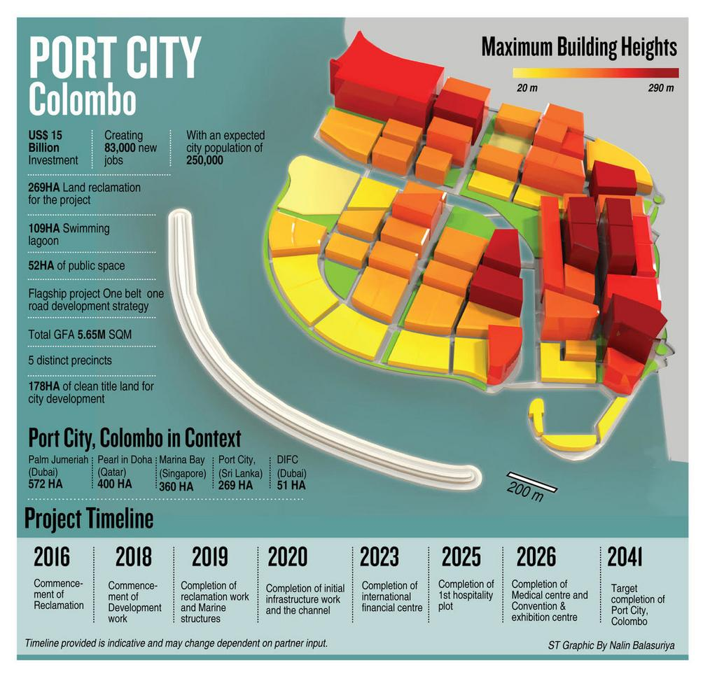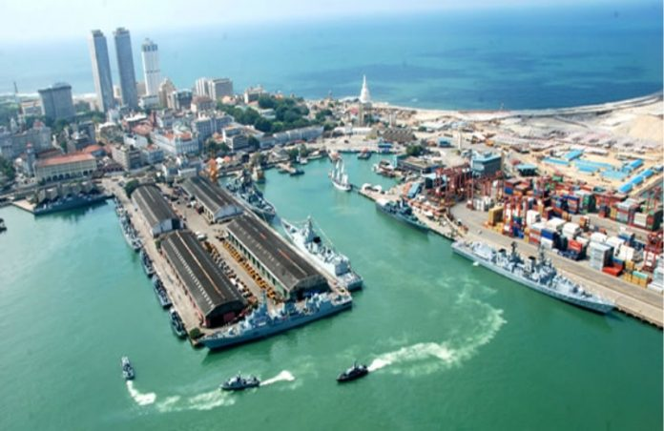**

**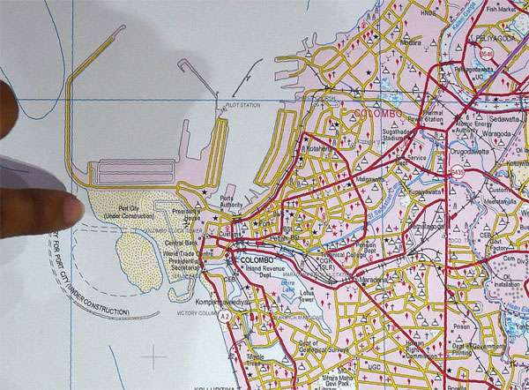**

**People's Movement Against Port City**

Religious leaders including Buddhist monks, Catholic priests, nuns, civic activists, Trade unions, Women, Local scientists/professionals and Fisher people have been fighting against one of the most controversial infrastructure project in Srilanka by the People's Movement Against Port City

**"**This project will displace 50,000 families and livelihoods of 30,000 poor fishermen living from Hendala to Negombo," and it will adversely affect our western and southern coast line including Panadura, Angulana, Mount Lavinia, Uswetakeiyyawa, and upto Negombo. The EIA of the project has not included the effect on sand and rock mining, the adverse impact on fish breeding areas, damage to coral reefs and coastal erosion, (Fr. Sarath Iddamalgoda, Vice president of the campaign).

On 6 March 2015, the project was suspended by the Sirisena government, citing allegations of corruption against the Rajapaksa Administration, and the absence of a feasibility study before the contract was awarded. Despite ecological concerns and allegations of corruption, in March 2016, the government resumed the port project, signifying its importance for Sri Lankan economy. On 12 August 2016, a Tripartite Agreement was signed by the Sri Lankan government, its Urban Development Authority (UDA) and the Chinese rm CHEC Port City Colombo Pvt. Ltd.

**Forms of Mobilization**

Creation of alternative reports/knowledge Development of a network/collective action Media based activism/alternative media Objections to the EIA Official complaint letters and petitions Public campaigns Street protest/marches Refusal of compensation

Environmental Impacts Potential: Biodiversity loss (wildlife, agro-diversity), Food insecurity (crop damage), Soil contamination, Large scale disturbance of hydro and geological systems, Floods (river, coastal, mudow), Noise pollution, Soil erosion, Deforestation and loss of vegetation cover

Socio-economic Impacts Potential: Displacement, Loss of livelihood, Loss of traditional knowledge/practices/cultures, Specic impacts on women, Land dispossession, Loss of landscape/sense of place

**Environmental Impact Assessment (EIA)**

The EIA process is laid down under the National Environment Act No 47 of 1980[[1]](#footnote-1) amended in 2000 as Act No 53. It is further prescribed in the Gazette No 772/22 of June 24, 1993. The process includes steps the project proponent should take in submitting preliminary information to the Central Environmental Authority (CEA).The developer then decided to expand the project by nearly 200 percent from 120 hectares (300 acres) to 233 hectares (575 acres). A lesser known fact is that, although the Port City is set to be 233 hectares in size, the extent of its total “footprint” is a massive 485 hectares or 1,200 acres including waterways and canals. On the basis of accessible information, experts assess the need for 200 million cubic metres of sand allowing 15-20% wastage (common practice when extracting sand from sea bed) and about 3.45 million cubic metres of quarry (granite) material from the hill country. This was probably done to achieve an increase in financial return on the developer’s investment at the expense of Sri Lanka’s environment and limited natural resources.

Concessions for the project

* Tax concessions to China for 25 years. (Sri Lanka will be denied this income for 25 years.)

The Concession Agreement places responsibility for obtaining all approvals on the SLPA.

• The Concession Agreement states that the Government of Sri Lanka is responsible for providing all service utilities including water, power, sewage and solid waste disposal, telecommunication required for the operation of the Colombo Port City with an estimated population exceeding one million people. (This would place a massive tax burden on Sri Lankans for at least 25 years.)

**Sand mining can erode beaches**

When sand is mined in quantity offshore, the affected sea area is filled by coastal erosion, altering the marine diversity. It adversely impacts marine sea bed weeds, depletes mangrove coastal areas as well as sea grass habitats and nesting places of endemic and endangered fauna. To re-sand a 1.5 to 2km stretch of beach requires 300,000 cubes of sand from deep sea at a current cost of Rs. 600,000,000. It would last about two years and be washed to another area, Coral reefs protect the coast from storms and erosion. They are the habitat for spawning and nursery ground for economically important fish species.That sand mining causing the destruction of coral reefs and spawning grounds and habitats of fish is already evident in Sri Lanka.

The situation of the fishing community is so desperate that the fisher folk have filed a case in the Supreme Court and they are represented by Senior lawyer J.C. Weliamuna. The Center for Environmental Justice has also filed a case through lawyer Ravindranath Dabare.

**Quarry material**

The Supplementary Environmental Impact Assessment (SEIA) of the Colombo Port City project states that 3.45 million cubic metres of large granite blocks will be needed for the construction and for this 20% of the hills to be mined using explosives. So Srilanka is heading for a period where there will be more landslides.”(The Sunday Times 02-11-2014)

Both sea sand and quarry material have “opportunity cost” – an economic term meaning “value of the best opportunity foregone” and the environmental cost of the consequences. The developer has assigned scant importance to the value of these natural resources or its associated environmental consequences (Eng. Channa Fernando)

To assist the developer, the Government has even offered offshore sand free-of-charge. Even the “royalty fee” incurred in using this country’s limited resources has been waived. Eng. Channa Fernando estimates US$ 1.7 billion for even less than half the volume of sand estimated for this construction. Sri Lanka’s investment is thus well in excess of China’s investment for the Colombo Port City project.

***Environmental Hazard***

The construction of the 233ha or 575 acres Colombo Port City adjacent to the Colombo South Terminal reduce the strength and alter the current flow between the Sri Lanka’s coast and its distal coral reefs resulting in a relatively still body of water. This would cause an increase in pollution due to reduced dilution of pollutants.

The increased sedimentation of toxic heavy metals (from unprocessed industrial waste) may result in thei getting into the food chain via detritus feeders fauna found in coastal waters. Nearly two thirds of the protein consumed by Sri Lankan people comes from the sea. Hence there is a risk that people may consume heavy metals via the food chain.

It appears that no comprehensive project feasibility study encompassing technical, socio-economic, environmental and financial aspects has been made for this project. Such a study would have identified alternative development concepts and implementations, such as whether it should be full-scale development or one that is phased out. It would have considered the project’s socio-economic benefits an impacts on the country at large, as well as financial returns. It would have also looked into the required upgrading of existing utility services.

The world speaks of sustainable development goals which satisfy the three pillars of social, economic and environmental development. The CPC project seems to violate this concept.

To ignore the views of people whose lives and livelihoods are affected by the Colombo Port City Project is irresponsible and not in keeping with good governance. We strongly believe that the views of people can’t be ignored by a democratic government. We urge the President, the Prime Minister and Cabinet to give a hearing to the appeal of the people of our country and to halt the Colombo Port City project or alter the destructive aspects elaborated above, and thereby ensure the safety of our people and our country.

Source:3/28/2019 Why the Port City is bad for the country | The Sunday Times Sri Lanka

[www.sundaytimes.lk/160612/sunday-times-2/why-the-port-city-is-bad-for-the-country-196859.html 3/4](http://www.sundaytimes.lk/160612/sunday-times-2/why-the-port-city-is-bad-for-the-country-196859.html%203/4)

**POINT PEDRO**

* The eastern coast of Point Pedro forms a 3-mile-wide, 20 mile long beach with sand dunes up to 100 feet high, extending to Thalayady. The porous soil has a water table deep underground with an estimated one billion litres of fresh water. The [Boxing Day tsunami of 2004](https://en.wikipedia.org/wiki/2004_Indian_Ocean_earthquake_and_tsunami) raised the salt content of the ground water. The tsunami destroyed parts of the town and submerged some parts with sea water up to 4 feet deep.
* Point Pedro has a small harbour, which is controlled by the Sri Lankan army.

Point Pedro consists of 14,057 families in 35 Grama Niladhari divisions out of which 2,900 families are fisher families, organised into 16 cooperative societies and one federation. For over 30 years of war, the fisheries industry in the area stood at a standstill and today revival seems like an uphill task with the rest of the world and country having moved on to bigger boats and better technology.

“In the 1980s, the Northern Province contributed to 40 percent of the catch; after the war it stood at four percent. We have managed to increase it to 17 percent in the last few years, but this is the maximum we can go with the current facilities,” said Prabath Ranaweera, the Project Officer assigned by the Fisheries and Aquatic Resources Ministry for the modernisation of the old Point Pedro Fisheries Harbour.

Ranaweera who has been an active proponent of the project explained that the government’s intension was to motivate more fishermen to get into deep sea fishing in the area as fish catches in the coastal belt were expected to dramatically fall in the next 10 years. “This harbour will be able to accommodate 150, 27ft boats. The South has 20 fisheries harbours; the North also needs them if they are to develop the fishing industry. At present, they can’t dock a large multi-day boat even if they get one.”

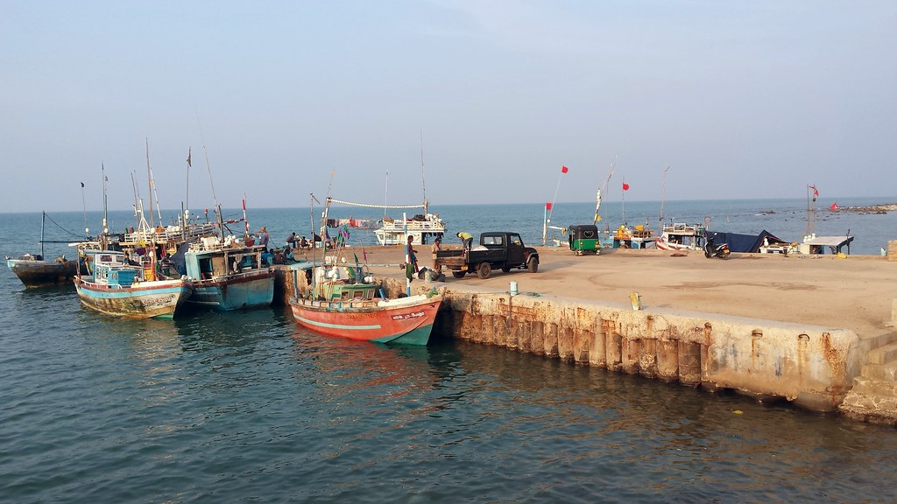According to the Initial Environmental Examination (IEE) Report performed in July 2018 for the project, the new harbour is set to be an all-weather fisheries harbour consisting of two breakwater structures (880m and 425m), a 18.4 ha harbour basin, two jetties (120m and 115m), 6.4 ha area of reclaimed land (the inshore intertidal reef complex will be reclaimed), two quay walls for parking of boats and slip way able to handle vessels up to 75m.

Apart from the harbour construction, the area will also have a net mending hall, community hall and canteen, bachelor quarters, harbour manager quarters, surveillance building, auction hall, parking areas, public toilets, wastewater treatment facility, security facilities, weigh bridge and control room, fuel facility, off-loading building, transformer and generator facilities. Massive undertaking, Ranaweera explained that they had done a feasibility studies prior to the designing of the project and identified that the main social impacts were likely to be caused to two important set of stakeholders: 13 fisher families on one side and three schools on the other side

**PESALAI HARBOR**

The fishery landing site in Pesalai located in the northern coastline of Mannar Island and the Silavatturai site located in the mainland coastline south of Mannar Island, have been identified by the Department of Fisheries and Aquatic Resources Development (DFARD) as possible locations for the development of Fishery Harbors in Mannar District. Pesalai was identified as the best site for a fully developed Fishery Harbor in the Mannar Island with the potential to accommodate IDAY and IMUL Boats. The proposed site is located in the eastern part of the northern coastline of the Jaffna Peninsula. This would provide safe navigational access and shelter for fishing crafts throughout the year. The Site is situated in the administrative division of Pesalai North (MN-57) and Pesalai West (MN-55) which belongs to Grama Niladhari Divisions (GND) of Mannar Divisional Secretariat Division in Mannar District. The proposed project site falls in the local authority limits of Pesalai Pradeshiya Sabha. The site is easily accessible, and the Mannar-Thalai Mannar Road runs along the area.

The IEE identifies the anticipated adverse environmental impacts of the project. During the construction phase, main potential adverse impacts that might occur include impacts on coral reefs (primarily at the Point Pedro harbor site) as a result of marine works; shoreline instability associated with dredging operations; and impacts associated with dredged waste disposal. Potential impacts that may occur during the operations phase of the project include shoreline instability associated with dredging operations, particularly in the course of regular maintenance dredging; impacts as a result of failure to perform adequate maintenance dredging;

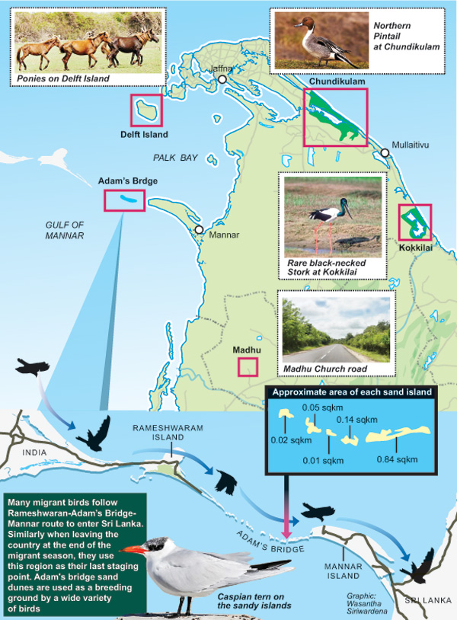

**Chundikkulam Lagoon**

Chundikkulam Lagoon is a [lagoon](https://en.wikipedia.org/wiki/Lagoon) in [Jaffna District](https://en.wikipedia.org/wiki/Jaffna_District) and [Kilinochchi District](https://en.wikipedia.org/wiki/Kilinochchi_District), north-east [Sri Lanka](https://en.wikipedia.org/wiki/Sri_Lanka). The town of Chundikkulam is located on a narrow piece of land between the lagoon and the [Indian Ocean](https://en.wikipedia.org/wiki/Indian_Ocean). The lagoon is sometimes referred to as Elephant Pass Lagoon.

The lagoon is fed by a number of small [rivers](https://en.wikipedia.org/wiki/River) from the south, including [Kanakarayan Aru](https://en.wikipedia.org/wiki/Kanakarayan_Aru" \o "Kanakarayan Aru), [Netheli Aru](https://en.wikipedia.org/wiki/Netheli_Aru" \o "Netheli Aru) and [Theravil Aru](https://en.wikipedia.org/wiki/Theravil_Aru" \o "Theravil Aru). It used to be linked to [Jaffna Lagoon](https://en.wikipedia.org/wiki/Jaffna_Lagoon) but since the construction of the [causeway](https://en.wikipedia.org/wiki/Causeway) at [Elephant Pass](https://en.wikipedia.org/wiki/Elephant_Pass) the lagoon has in effect been a [lake](https://en.wikipedia.org/wiki/Lake). The lagoon's water is [brackish](https://en.wikipedia.org/wiki/Brackish).

The lagoon is surrounded by [palmyrah palm](https://en.wikipedia.org/wiki/Borassus_flabellifer" \o "Borassus flabellifer) [plantations](https://en.wikipedia.org/wiki/Plantations) and [scrubland](https://en.wikipedia.org/wiki/Scrubland). The land is used by [prawn](https://en.wikipedia.org/wiki/Prawn) [fishing](https://en.wikipedia.org/wiki/Fishing) and some [salt](https://en.wikipedia.org/wiki/Salt) production. The lagoon has small areas of [mangrove swamp](https://en.wikipedia.org/wiki/Mangrove_swamp) and [sea grass](https://en.wikipedia.org/wiki/Sea_grass) beds. The lagoon attracts a wide variety of [water birds](https://en.wikipedia.org/wiki/Water_bird) including [storks](https://en.wikipedia.org/wiki/Storks), [ibis](https://en.wikipedia.org/wiki/Ibis), [ducks](https://en.wikipedia.org/wiki/Ducks), [coot](https://en.wikipedia.org/wiki/Coot), [gulls](https://en.wikipedia.org/wiki/Gulls) and [tern](https://en.wikipedia.org/wiki/Tern).

Most of the lagoon was designated a [bird sanctuary](https://en.wikipedia.org/wiki/Chundikkulam_Bird_Sanctuary) in 1938.

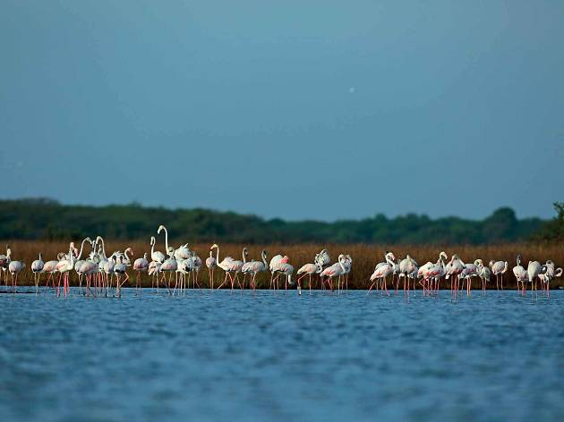

The Chundikulam Bird Sanctuary is located nearly 2 hours south/east from North Gate by Jetwing via road. The drive takes you out of the city and into the busy suburbs of Jaffna, before crossing over to the northeastern edge of our tear drop-shaped isle where the sanctuary rests between the lagoon and the sea.

Chundikkulam Lagoon is partly surrounded by [mangrove swamps](https://www.revolvy.com/page/Mangrove-swamp) and [sea grass](https://www.revolvy.com/page/Sea-grass) beds.[1] The surrounding area includes [palmyrah palm](https://www.revolvy.com/page/Palmyra-palm" \t "_blank) plantations, [scrub](https://www.revolvy.com/page/Scrubland) forests and a variety of dry zone flora.[1][10] Numerous varieties of [water](https://www.revolvy.com/page/Water-bird) and [water](https://www.revolvy.com/page/Wader) birds are found in the park including [bar-tailed godwit](https://www.revolvy.com/page/Bar%252Dtailed-godwit), [black-tailed godwit](https://www.revolvy.com/page/Black%252Dtailed-godwit), [black-winged stilt](https://www.revolvy.com/page/Black%252Dwinged-stilt), [brown-headed gull](https://www.revolvy.com/page/Brown%252Dheaded-gull), [common sandpiper](https://www.revolvy.com/page/Common-sandpiper), [curlew sandpiper](https://www.revolvy.com/page/Curlew-sandpiper), [eurasian coot](https://www.revolvy.com/page/Eurasian-coot" \t "_blank), [eurasian curlew](https://www.revolvy.com/page/Eurasian-curlew" \t "_blank), [eurasian spoonbill](https://www.revolvy.com/page/Eurasian-spoonbill" \t "_blank), [eurasian teal](https://www.revolvy.com/page/Eurasian-teal" \t "_blank), [eurasian wigeon](https://www.revolvy.com/page/Eurasian-wigeon" \t "_blank), [garganey](https://www.revolvy.com/page/Garganey" \t "_blank), [greater flamingo](https://www.revolvy.com/page/Greater-flamingo), [gull-billed tern](https://www.revolvy.com/page/Gull%252Dbilled-tern), [marsh sandpiper](https://www.revolvy.com/page/Marsh-sandpiper), [northern pintail](https://www.revolvy.com/page/Northern-pintail), [oriental ibis](https://www.revolvy.com/page/Oriental-ibis), [painted stork](https://www.revolvy.com/page/Painted-stork), [ruff](https://www.revolvy.com/page/Ruff), [shoveler](https://www.revolvy.com/page/Shoveler" \t "_blank), [terek sandpiper](https://www.revolvy.com/page/Terek-sandpiper" \t "_blank) and [wood sandpiper](https://www.revolvy.com/page/Wood-sandpiper).[1][14] Mammals found in the park include [leopard](https://www.revolvy.com/page/Leopard), [sloth bear](https://www.revolvy.com/page/Sloth-bear) and [deer](https://www.revolvy.com/page/Deer).[10] [Mugger crocodile](https://www.revolvy.com/page/Mugger-crocodile) and [saltwater crocodile](https://www.revolvy.com/page/Saltwater-crocodile) have also been seen in the park.[15]

Irrespective of its limits, toward attaining the sanctuary a single should really get the A9 street against Jaffna, and brain toward the Iyyakkachchi junction, passing the Elephant pass. Commitment a further 15 km motivation in opposition to Kaddaikadu, right until on your own come at the Chundikulam junction. The highway throughout the Sanctuary falls among Chundikulam towards the northern stop and Chalai against the southern finish, functioning parallel in direction of the coastal line. Upon journeying in direction of the North, palmyrah arms inside of the length silhouetted from the rays of the sunlight together with scrublands, broad elements of grass lands and the standard environment of dryer sections of this area demonstrate an entirely alternative practical experience in opposition to other components of Sri Lanka. Considerably of the forest crops is made up of Palu (Manilkara hexandra) and Weera (Drypetes sepiaria) dominant dry forest style. The dry zone forest deal with his a house in direction of the bigger mammals these as the sloth go through, jackal, sambar, and deer, even though lesser mammals these as mongoose, otter, ring tail civet, fishing cat, and jungle cat, can much to be discovered.

**Highlights**

Chundikulam sits in the middle of the strip of land that joins the Jaffna peninsula to the rest of the island. At its east is the Indian Ocean and at its west the Jaffna lagoon. In this arid, wildland, many kinds of habitats have evolved beaches with sand-dunes, salt marshes, wetlands, thorny scrublands, dry forests, tanks, mangroves and of course the lagoon. This means that a great number of birds, favouring a great number of terrains, can flock and thrive within the area.

Chundikkulam Lagoon is partly surrounded by mangrove swamps and seagrass beds. The surrounding area includes palmyra palm plantations, scrub forests and a variety of dry zone flora. Numerous varieties of water and wader birds are found in the park including bar-tailed godwit, black-tailed godwit, black-winged stilt, brown-headed gull, common sandpiper, curlew sandpiper, eurasian coot, eurasian curlew, eurasian spoonbill, eurasian teal, eurasian wigeon, garganey, greater flamingo, gull-billed tern, marsh sandpiper, northern pintail, oriental ibis, painted stork, ruff, shoveler, terek sandpiper and wood sandpiper. Mammals found in the park include leopard, sloth bear and deer. Mugger crocodile and saltwater crocodile have also been seen in the park

**CHUNDIKULAM NATIONAL PARK**

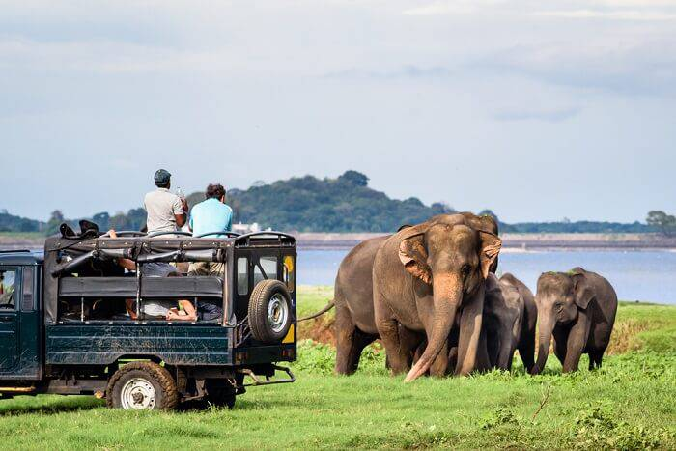

This is located in northern Sri Lanka. The nearest city to this national park is Kilinochchi. It is at a distance of 12 km from Chundikulam national park. It sits in the middle of Indian Ocean towards east and Jaffna lagoon towards west. Surrounded by long trees and dense forest this place will be a dreamland.Leafing out versus the mainland towards south of the northern peninsula, the stem of skinny strip connecting equally finishes, bordered by the Indian Ocean against the east, and carving toward crank out a lagoon towards the west is a divine hotspot of wild creatures that's been concealed for just about a few many years

Its undulating surroundings include previously mentioned the long time made a higher quantity of habitats. Versus seashores laden with sand-dunes, in direction of salt marshes, towards wetlands, in the direction of thorny scrublands and dry forests, toward tanks, mangroves and lagoon include all put together in the direction of crank out a wild haven.

In January 2009 the [Sri Lanka Army](https://www.revolvy.com/page/Sri-Lanka-Army)'s [55 Division](https://www.revolvy.com/page/55-Division-(Sri-Lanka)), advancing from [Nagar Kovil](https://www.revolvy.com/page/Nagar-Kovil), re-captured the area around Chundikkulam sanctuary from the [militant](https://www.revolvy.com/page/Sri-Lankan-Tamil-militant-groups) [Liberation Tigers of Tamil Eelam](https://www.revolvy.com/page/Liberation-Tigers-of-Tamil-Eelam).[[2]](#footnote-2) Subsequently the [Sri Lankan military](https://www.revolvy.com/page/Sri-Lankan-military) started building military bases in the sanctuary and barred local fishermen from using the sanctuary and local residents from returning to their homes. The army opened the Chundikulam Nature Park Holiday Resort in the northern part of the sanctuary in January 2012.

Following the end of the [Sri Lankan Civil War](https://www.revolvy.com/page/Sri-Lankan-Civil-War) the government announced plans to convert various [sanctuaries](https://www.revolvy.com/page/List-of-wildlife-sanctuaries-of-Sri-Lanka) in the [Northern Province](https://www.revolvy.com/page/Northern-Province,-Sri-Lanka) into [national parks](https://www.revolvy.com/page/List-of-national-parks-of-Sri-Lanka). An Integrated Strategic Environmental Assessment of Northern Province produced by the government with the assistance of [United Nations Development Programme](https://www.revolvy.com/page/United-Nations-Development-Programme) and [United Nations Environment Programme](https://www.revolvy.com/page/United-Nations-Environment-Programme) and published in October 2014 recommended that Chundikkulam sanctuary be extended westwards towards [Elephant Pass](https://www.revolvy.com/page/Elephant-Pass) and south-east wards towards Chalai and Pallamatalan and be upgraded to a national park. The recommendation would see the sanctuary's area grow from 11,149 ha (27,550 acres) to 19,565 ha (48,347 acres), partly as a result of absorbing state-owned forests nearby.

In May 2015 the government announced that Chundikkulam, along with [Adam's Bridge](https://www.revolvy.com/page/Adam%27s-Bridge-Marine-National-Park), [Delft](https://www.revolvy.com/page/Delft-National-Park) and [Madhu Road](https://www.revolvy.com/page/Madhu-Road-National-Park" \t "_blank), would be designated national parks. Chundikkulam sanctuary became a national park on 22 June 2015 with an area of 19,565 ha (48,347 acres).

**HAMBANTOTA PORT**

The construction of Hambantota Port is one of the major development projects that had been undertaken by Sri Lanka ports Authority. This port development work is scheduled to implement in phases. Phase I developments have already been completed while phase II development is in progress.  
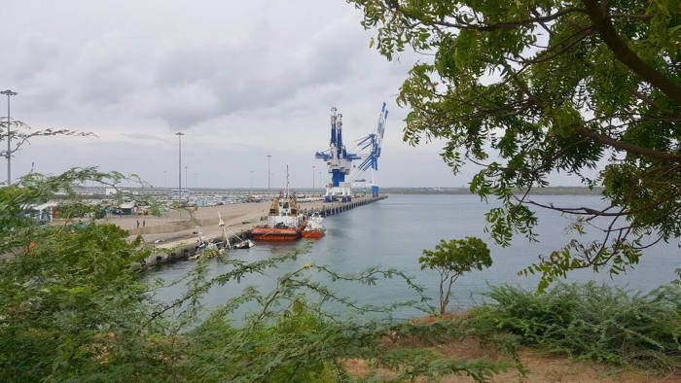  
This port is located very close proximity to the major international east-west shipping route and well positioned at a strategic location on maritime gateway to India. Large number of ships passes Sri Lanka daily along this shipping route and creates good business opportunities for providing services like supply of fuel, water, crew change in addition to the usual port operations.On domestic trade perspectives, it is better positioned with direct roadway connection to the southern, central and eastern areas of the island and serves Southern half of the island through linking with the Central and Eastern province by roads.  
  
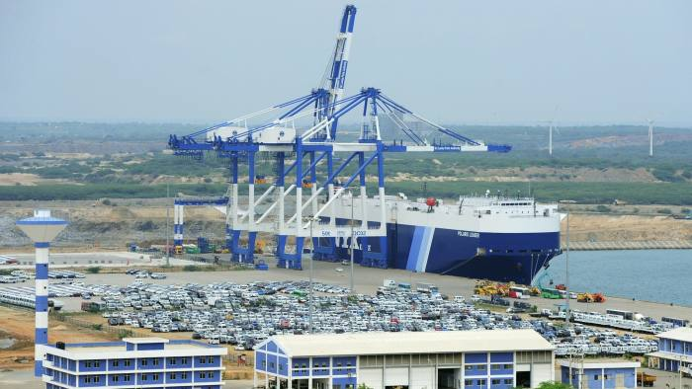

The harbor area is basically protected by 312m and 988m long two breakwaters. An access channel of 210 m width and 17m depth is provided with a turning circle of 600m diameter and 17m deep to facilitate vessels up to 100,000 DWT. (<http://www.slpa.lk/port-colombo/mrmr>)  
  
China Merchants Port Holdings Co., the state-owned Chinese port operator, will agree to pay $1.12 billion for a 70% share of the Hambantota port for 99 years, a portion of which is to be put towards a cut of a new company called the Hambantota International Port Services Company (HIPS), and the remaining $146.342 million put into a bank account to cover operational expenses. China Merchants has also agreed to invest an additional $600 million into the development of the struggling port, which has so far incurred $300 million in losses.

By 2012, the port was struggling to attract ships — which preferred to berth nearby at the Colombo port — and construction costs were rising as the port began expanding ahead of schedule.

Between 2009 and 2014 the country’s total government debt tripled and external debt doubled, amounting to $64.9 billion — $8 billion of which is owned by China. 95.4% of all government revenue went towards debt repayment, with a third of all earnings going to China. This dire situation resulted in a $1.5 billion IMF bailout in 2017

China Merchants Port Holdings Co., the state-owned Chinese port operator, agreed to pay $1.12 billion for a 70% share of the Hambantota port for 99 years, a portion of which is to be put towards a cut of a new company called the Hambantota International Port Services Company (HIPS), and the remaining $146.342 million put into a bank account to cover operational expenses. China Merchants also agreed to invest an additional $600 million into the development of the struggling port, which had incurred $300 million in losses by 2017.[Repetition] This project will result in Oil spills, Surface water pollution / decreasing water (physico-chemical, biological) quality, Other Environmental impacts. There is already displacement, land disposition and loss of livelihood for farmers and coastal communities

The issue is still ongoing and more people might be displaced in the near future. It is not sure if the CM Port will follow all the environmental and social regulations, so there are still large uncertainties.[[3]](#footnote-3)

For Beijing, the Hambantota project is a linchpin of the “One Belt One Road” project, which aims to build a new Silk Road of trade routes between China and more than 60 countries in Asia, the Middle East, Africa and Europe. That project is underpinned by a network of harbours across the world that have put China in a position to challenge the US as the world’s most important maritime superpower. Other similar developments in the region include the Gwadar port in Pakistan, which is the centrepiece of the $55bn China-Pakistan Economic Corridor. But some have accused Beijing of using projects such as this to increase its regional political power, noting the length of the lease agreed by Sri Lanka is the same as that which gave Britain control over Hong Kong in the 19th century. Constantino Xavier, a fellow at foreign policy think-tank Carnegie, said: “This is part of a larger modus operandi by China in the region. Hambantota port lying virtually empty last month © Simon Mundy “Beijing typically finds a local partner, makes that local partner accept investment plans that are detrimental to their country in the long term, and then uses the debts to either acquire the project altogether or to acquire political leverage in that country.” New Delhi has become so concerned about Beijing’s plans at Hambantota that it has entered talks with Sri Lanka to operate an airport nearby. In recent months, however, there have been signs that China’s partners are starting to become wary over the terms being dictated to build projects under the One Road banner. Pakistan, Nepal and Myanmar have all recently cancelled or sidelined major hydro electricity projects planned by Chinese companies. The projects would have been worth a total of $20billion.[[4]](#footnote-4)

**CASE STUDIES**

***Plight of SSF in Northern Province***

* Before the adoption of blue economy, katamarans were used and shoreline nets like gillnets were used traditionally. In 60s Nylon nets with Yamaha inboard engines were used for deep-sea fishing. In 70s Norwegian crafts were introduced especially pursenie nets for trawlers. This was banned for some time as fish stocks were destroyed heavily.
* From 83’ onwards, deep-sea fishing was stopped and shoreline fishing was in practice due to the ethnic conflicts. Sri Lanka entered with agreement with India to banned bottom trawling by fisherman from, Karaikal, Rameswaram, Nagapattinam, Kodiyakarai, Mallipatinam, Mimisal, and Thondi of Tamil Nadu in Mannar coast. Nearly 5000 ~~boats~~ Mechanized boats from Tamil Nadu were exploiting the resources of Northern coast of Sri Lanka.
* In 2002 offshore fishing was started again. But small-scale fishers protested against pursein trawling as 18 kgs of fingerlings were destroyed to catch 1 kg of ~~fish~~[Prawns]. From 2004 to 2009 fish catch was stopped due to the war. Around 2010 another peace agreement India and Srilanka fisheries sector was made to regulate the distance and timing of Indian boats. Before the onset of war, Northern Province contributed 43% of fisheries production. After the war, it was reduced 9%. At present 23% is the Contribution from Northern Province.[[5]](#footnote-5)
* In Jaffna 48,000 to 50,000 families are involved in traditional fishing. 1500 families are engaged with trawlers. In 2017 bottom trawling was banned officially. Ring seine nets, and LED lights were banned for catching sea cucumber. But dynamites are used for trawling.
* As part of Blue Economy, in Mathagal coast offshore wind energy project through wind mill a joint venture of China and Malaysia was stopped by the protest of the people. Though it is claimed that B.E has inclusive growth model Northern Province is not equipped with modern technology. Instead of fishing harbor, commercial harbors are being constructed. There is no access to deep-sea fishing. Multi day boats (17 ½ ft length with outboard engine) are given to fishermen of South. More over Mullaitheevu is declared as shrimp bank. From January to March there will be good catch of prawn. But there is no regulation by the State Government to stop Indian trawlers. From the Coast to 100 meter is declared as the buffer zone.

The Coastal lands are occupied by tourism industries under the care of Military. In Jaffna 3600 acres of paddy fields are converted into shrimp farms. Oil and Natural gas exploration is going on in Mannar basin. Ambarai coast is set aside for waste disposal. As part of Blue Economy, foreign vessels registration Act 2018 has allowed the Chinese vessels to occupy the coast of Northern Province. There are 82,000 single women. At present access to drinking water is denied due to salinization of ground water.

**FGD 1, 10th October 2018**

FGDs withLeaders of Northern Province Fisher People’s Unity [NPFPU]

* M.M. Aalam- Mannar, Ex-Chair of Mannar district fisheries coop society union, Chair, NPFPU,
* N.Subramaniyam- Jaffna, Ex-chair of Northern Province Fisheries Cooperative Society Union and Secretary of NPFPU
* Francis Joseph-Kilinochchi, Chair, Nachchikuda, Poonagari Fisheries Coop Union, Member, NPFPU,
* A.Mariarasa – Mulaitivu, Ex-chair Mulativu district fisheries coop union, Treasurer, NPFPU,
* S. Rajachandran –Jaffna, Chairperson, ~~Guru~~ Karainaggar fisheries coop society union, member of NPFPU,

REPETITION

* Before the adoption of blue economy katamarans were used and shoreline nets like gillnets were used traditionally.
* In 60s Nylon nets with Yamaha inboard engines were used for deep-sea fishing. In 70s Norweign crafts were introduced especially pursein nets for trawlers. This was banned for some time as fish stocks were destroyed heavily. From 83 onwards, deep-sea fishing was stopped and shoreline fishing was in practice due to the ethnic conflicts. Srilanka entered with agreement with India to banned bottom trawling by fisherman from, Karaikal, Rameswaram, Nagapattinam, Kodiyakarai, Mallipatinam, Mimisal, and Thondi of Tamil Nadu in Mannar coast. Nearly 5000 boats Mechanized boats from Tamil Nadu were exploiting the resources of Northern coast of Srilanka. In 2002 offshore fishing was started again. But small scale fishers protested against purse seine trawling as 18 kgs of fingerlings were destroyed to catch 1 kg of fish. From 2004 to 2009 fish catch was stopped due to the war. Around 2010 another peace agreement India and Srilanka fisheries sector was made to regulate the distance and timing of Indian boats[[6]](#footnote-6). Before the onset of war, Northern Province contributed 43% of fisheries production. After the war, it was reduced 9%. At present 23% is the Contribution from Northern Province.
* In Jaffna 48,000 to 50,000 families are involved in traditional fishing. 1500 families are engaged with trawlers. In 2017 bottom trawling was banned officially[[7]](#footnote-7). Ring seine nets, and LED lights were banned for catching sea cucumber. But dynamites are used for trawling .
* As part of Blue Economy, in Mathagal coast offshore wind energy project through wind mill a joint venture of China and Malaysia was stopped by the protest of the people. Though it is claimed that B.E has inclusive growth model Northern Province is not equipped with modern technology. Instead of fishing harbor, commercial harbors are being constructed. There is no access to deep-sea fishing. Multi day boats (17 ½ ft length with outboard engine) are given to fishermen of South. More over Mullai theevu is declared as shrimp bank. From January to March there will be good catch of prawn. But there is no regulation by the State Government to stop Indian trawlers. From the Coast to 100 meter is declared as the buffer zone.
* The Coastal lands are occupied by tourism industries under the care of Military[[8]](#footnote-8). In Jaffna 3600 acres of paddy fields are converted into shrimp farms. Oil and Natural gas exploration is going on in Mannar basin. Ambarai coast is set aside for waste disposal. As part of Blue Economy foreign vessels registration Act 2018 has allowed the Chinese vessels to occupy the coast of Northern Province. There are 82,000 single women[Women Headed Households]. At present access to drinking water is denied due to salinization of ground water.

**FGD 2.1, Interfacing with Ministers**

* Minister of Women Affairs of Northern Provincial Council- Ms. Anandee Shasheedaran [Tamil National Alliance], She attended Geneva based international advocacy campaign even after elected as the minister. She mainly shared that there is no devolution of powers and funds to Northern Province by the central Government. She strongly opposed the policy of the Government to permit Army to control and manage the development interventions including Tourism, Agriculture, and Restaurant managing marine protected areas. The Government has not evolved any concrete plan to support the single women and the women headed house numbering around 82,000. They do not have access to shelter and productive employment avenues to earn their livelihood. They face gender violence. The issues related to infrastructure facilities, access to drinking water, health care services, schools and educational support, transport facilities are not yet addressed. The land acquired by the army from the private owners for construction of tourism industries, hotel, restaurant, in mullaitheevu, vavunia, mannar were not given compensation or alternate sites or houses. The displaced people living IDP camps continue to live in appalling condition.

**FGD 2.2 Meeting with Minister of Fisheries, Northern Provincial Council – Mr. Kandaih Sivanesan.**

Access to drinking water is an acute problem face by the Northern Province especially Jaffna District. So check dams are constructed across the rivers and lagoons in order to prevent them from reaching the sea and remain as fresh water source. We have not studied the implication of such interventions on the ecological services. As this is the centralized decision we cannot have access to information and there is no devolution of power or funds. The 13th amendment to the constitution as pressurized by the Indian state for devolution of powers and funds to the Northern Province by the Central Government is still a distant dream. The harbors at Pesalai and Point pedro though claim to benefit the fishing community of the North western province, the fishing community is opposing the projects for the reason that they do not have access to buy multi day boats and deep sea vessels as they are heavily indebted already and there is no credit support from the Government. We are suspicious that this two harbors are built for the southern fishers to anchor there MD boats and deep-sea boats. The shoreline fisheries will be totally affected. The families dependent on shoreline fishing especially women vendors will be totally displaced and there will be impact on the fish stock and bio-diversity of species.

**FGD 3, 11th October 2018**

Meeting with the Leaders of affected communities of Chundikulam Nature Reserve

Chundikulam is one of the important military base for LTTE till the end of the war at 2009 and from 2009 onwards the Sri Lankan Navy destroyed the LTTE base and brought the area (lagoon and the coastal stretches) under its control. The fishermen of this area were restricted to catch fish by LTTE and they had to avail permission to catch fish in the 27 fishing grounds in the lagoon area. In 1938, the Sri Lankan government constructed a Birds Sanctuary. After the end of the war, infrastructure projects were built in ‘Yanai Eravu’ (Elephant Pass) and the Sanctuary was expanded for setting up a National Park. Subsequently the Sri Lankan military started building military bases in the sanctuary and barred local fishermen from using the sanctuary and local residents from returning to their homes.

***Chundikulam National Park is a Marine Protected Area.[[9]](#footnote-9)***

At present, the declaration and management of MPAs is carried out without adequate consideration of the ecology, socioeconomic realities, or long-term management sustainability. During the expansion phase after 2015 many fishing families depended on Chundikulam lagoon were displaced without any concrete plan for their resettlement livelihoods.

Government forces occupied territory to set up military camps, or bases, for operations, and demarcated certain areas as High Security Zones (HSZs), thwarting their return. It not only established barracks, but has used the land for agriculture, tourism, and other commercial ventures. according to the government, as of 2017, nearly 40,000 people remained internally displaced in the country, a majority from Jaffna.

While the government typically defends the military occupation of land as important for national security, in most cases that rationale is suspect. The use of the land for tourism or agriculture points to the real interest rooted in commercial gain. In at least four sites included in this report, land occupied by the military under the pretext of national security is being utilized for commercial purposes. There are court cases and the victims of the process needs repatriation and justice.

The general absence of tenure and property rights with legal forms of representation is a major obstacle faced by coastal resource users because they are dependent mainly on customary rights. Failure to safeguard livelihoods and diminishing income from natural resources is driving increasing numbers of these unskilled and semi-skilled workers to foreign employment, particularly from Sri Lanka where most of the coastal poor live.

**FGD 4, 12th October 2018**

Meeting with People’s Movement against Port City [PMAPC] Core Committee Members;

* Subashinie Deepa- Co-convener,PMAPC
* Marcus Fernando-Chair, Negombo Lagoon Fisher People’s Organization
* Sr. Noel Christine- Religious leader, Congregation of Charity
* Aruna Roshantha- Chair, All Ceylon Fisher Folk Trade Union
* Loyel Peiris, Chair, National Fisheries Trade Union
* Nuwan Pradeep, Media Unit, NAFSO
* Grace Matilda, Chair, SVFWO,
* P. Prageeth, Right to Life HR Organization,
* The government of Sri Lanka has not only deregulated the existing legislations governing property rights, tenure rights and laws related to environmental protection. The amount of land being reclaimed, destruction of hillocks for the construction of port, displacement of coastal communities and other dependent communities, the ongoing environmental degradation and occupation of the area by the Chinese, opening up restaurants, hotels and tourist spots and malls by Chinese and other Multinational Corporations is a classical example for the impact of Blue Economy, where it has implications on the Socio, Economic, Political environment layers. The global accumulation of capital and the global governance by the imperialist countries like China through its MNCs and TNCs cannot be opposed by the existing campaigns / networks. This has to be challenged by the consolidation of People’s voice at the global level. Blue Economy depends on the finance capital in lieu of natural capital at the cost of human capital. The bilateral agreements between Srilankan government and the Chinese government through their agencies need to be studied to unearth the flaws and the violations against humanity and nature. Blue Economy aims at sustainability and inclusive approach but Colombo city project is not only economically unviable, it is ecologically unsustainable and irreversible displacing communities, exploiting ocean resources and other natural resources of hinter land. This movement is planning to move the international court of justice.

Sand mining is seriously impacting the country’s fishing community. Fish netted in our coastal waters provide two thirds of the protein consumed by our people. (Sinharaja Tammita-Delgoda, Island 18-11-201 Sri Lanka is classified as a developing country with a population of 21 million. The majority of the people of this island cannot afford to purchase deep sea fish, the much cheaper and daily netted fish from our coastal waters are their staple diet and to many their only thriving livelihood. The destruction of fishing communities and villages are now taking place: their homes washed away, some have no place even to park their boat because of sea erosion caused by sand mining. This environmentally destructive aspect of the Colombo Port City development could lead to serious socio-economic problems and malnutrition. It is estimated tha the number of fishermen directly affected is now in excess of 30,000 in Negombo alone. The overall figure including those engaged in associated trades is estimated to be more than 600,000.[[10]](#footnote-10)

**FGD 5, 13th October 2018**

Multiday Boat owners

Ericson Fernando, Abdon Mihindukula, Sisira Fernando

They go for 1 or 2 months and six persons will form a team per Trip Boat is imported from , Malaysia. They purchase food rations for 2 months. After Tsunami they can’t judge season changes. Atleast 20 million is required as capital. The engine speed is 350 HP ( Mitsubishi, Deawoo, Isuzu). Long line with winch. Middleman take lion’s share. But bank loans are than – house. 50% to labour. And 50% to owners. They are provided with communication radio. As there is labour shortage SL fishers are used as labourers in Seyshelles big foreign vessels. Madagascar, Mannar, Trinco and travelling for nearly six months.Multiday boats donot go to Batticaloa, Trinco. Seychalles vessels to go high seas.[NOT CLEAR THIS IDEA] VMS is only for High Sea boats greater than 40 feet.

**FGD 6, 14th October 2018**

Meeting with Women fishworkers [vendors, processors and women engaged in support services)

The research team met the leader and the members of a women’s collective in Negombo

* 3500 Households and many of them have only small daily boats. But not many fishermen are living here for 5 years. They belong to Kuttiduwa community. 10,000 people are dependant on post-harvest dependent livelihoods both male and female. All the women were displaced and living 1km away from the coast in the post tsunami reconstruction phase. Nearly 30% women are engaged in non-fishing activities for their livelihood. They have to hire auto to buy fish from the market during auctioning and they have to pay Rs 100 per trip. They do not sell prawn, only fish. They have pay levy to the market.

Big High-sea boats and Motarised boats from south land here for selling. Hence, the prices get reduced for fishers’ women. But vendors here prefer only fresh fish from Negombo boats. Only for dry fish, they buy from South big boats like tuna. Different species are available from boats coming from Negombo and south. The price is costlier in Negombo due to big trawlers, so they buy from south also.

Commission agents are lending money for vendors on a daily basis at 4% interest (48% per year) but women’s group extending loan at the rate 1% (12%). All fishers here are mostly labourers going to Batticaloa for their employment.

Even men are competing with women in post harvesting as fishing is not profitable. The dry fish vendors buy the cheapest fish when quality and timing is correct. Fish is sold at a higher price during morning hours and is sold for a lower price towards evening .Males buy at auction, Women aren’t part of any cooperative society. Fish traders and big commission agents buy dry fish from women vendors.

* Afte the construction of the Port city project, Suddenly sea water rushed in and destroyed dry fishing grounds . Never such a rush in 32 years. Erosion is a major problem. Original fishing grounds, spawning grounds are damaged .There are big holes in the sea due to continuous dredging for port. They protested and govt. agreed to dredge 10 kms ashore. But they don’t comply.Compensation was extended only for insured fishers.Rich dominated the church committee. Even for repairing houses in the Coastal zone, they have to avail permissions.

**FGD with Leader of Tamil National People Front Mr. Gajendra Kumar Ponnambalam**

According to him the present Government is showing apathy to war victims of Northern province especially coastal communities. The policy of Blue green economy was not discussed. The age-old occupation like palm products, extraction of arrack are not existing any more and communities dependant on them are being eliminated. There is scarcity of drinking water due to the depletion of ground water and incidence of people developing kidney storms is increasing.

**Discussion with Academicians**

Prof.Sumanasiri Liyanage Retired Professor of Economics. University of Peradeniya,

Prof. Oscar Amarasinghe, Retired Professor on Social & Economic on Agriculture at faculty of Agriculture Ruhuna University,

Prof. G.M. Kularathne, Head, the Social Science Center at department of Economics Kelaniya University

Prof. Ivan Silva, Former Chairperson, National Aquatice Resources Development Agency, [NAQDA]

**OBSERVATIONS / VIEWS**

In the name of Blue Economy Srilanka has adopted market led growth model which is the continuation of Neoliberal economy from 1977 onwards. Srilanka has shifted from production to trading similar to Singapore. The required growth rate is 9%. Under “Enterprise Srilanka”, Citizens are invited as co-owners Sri Lanka plans to create a [knowledge-based](https://en.wikipedia.org/wiki/Knowledge_economy) [social market economy](https://en.wikipedia.org/wiki/Social_market_economy) and an export-oriented economy as well as the [Western Region Megapolis](https://en.wikipedia.org/wiki/Western_Region_Megapolis) a [Megapolis](https://en.wikipedia.org/wiki/Megalopolis_(city_type)" \o "Megalopolis (city type)) in the western province to promote economic growth. The creation of several business and technology development areas island-wide specialized in various sectors, as well as tourism zones are also being planned. But Sri Lanka has recently been facing a danger of falling into economic malaise, with increasing debt levels and a political crisis which saw the country's debt rating being dropped (financial times 2018)

To address this, the government should eliminate price distortion, property rate according to market price. Sri Lanka has promoted blue green institute to execute the projects under blue green economy. In the Northern province, the Reservoirs which are the sources of drinking water, irrigation and hydro power are promoted for industrial aquaculture. This resulted in chronic health issues

The total fishing fleets were increased 48 % within fifteen years (from 1999- 2015). Non-motorized boats were increased 31% and motorized boats were up to 60% level on the above period of time. As per fishery statistics the fishing pressure of the coastal region is reached up to maximum level because the fish production from the coastal fishery estimated that Maximum Sustainable Yield (MSY) 250,000 Mt. The yield of coastal fishery was reported 269,020 Mt in 2015. Therefore it would seem to be reached to overexploited level. The fleets that engaging the offshore fishery also were increased 68%.

**University of Jaffna**

* Prof. A. Soosainathan[Geography Dept.] & Dr. S. Raveendran[Information Technology]
* According to them the Srilankan Government is promoting deep-sea fishing. It is giving subsidy and credit support to deep-sea fishing and multi day boat owners in the southern region. Then Nothern Province still following traditional gears and crafts. They livelihood was earlier disrupted by LTTE. But after the war the military has taken over the development function such as promoting tourism, agriculture, running real estate business, hotel industries and managing marine protected areas. It was grabbed vast stretches of coastal land and farm lands for constructing military bases, tourism industries and residential blocks. The women are the worst affected victims and there is no social security for the single women. The ecological and economic implication of blue economy need to be studied. They recollected the strike in 2012 against the closure of university and privatization of education. There was hike in the education fees and health care was costly affair. The infrastructure facilities need to be addressed.

**Discussion with Dr. Ahilan Kadiragamar, Political economist at Jaffna, active member**

Fisheries in the North recovering from the devastating war are crippled by the persistent poaching of trawlers from Tamil Nadu. Of the 7500 trawlers in Tamil Nadu, 2000 are fully or partly dependent on Sri Lankan waters for making ends meet. In Tamil Nadu, fishers and politicians have framed this issue as one of bona-fide fishers hammered by the Sri Lankan Navy. Furthermore, the root cause has been popularly attributed to Indira Gandhi ‘giving away’ traditional fishing grounds including Kachchatheevu to Sri Lanka in 1974. In reality, to secure a profitable catch, Indian trawlers move deep into Sri Lanka’s northern and eastern coastline.

The encroachment of Indian trawlers, the joint ventures with East Asian vessels as part of Sri Lanka’s development push and the interference of the EU have a common impact. They cripple small-scale fishers who are powerless in the face of decisions taken at the level of states and international forums.

The development argument in Sri Lanka,that supporting technologically ‘inefficient’ small-scale fisheries is economically unrealistic and naïve, does not hold. The alternatives for men and women from the fishing community have been either migrant work in the Middle East and countries such as Italy, or work in the garment factories in the Free Trade Zones. Both options consist of temporary migration uprooted from their communities and families, comprising mainly unskilled precarious work. Compared to these options, small scale fisheries continue to have potential for decent livelihoods with dignity, provided trans-national and mega development driven dispossession is kept at bay.

4/9/2019 Second Wave of Neoliberalism: Financialisation and Crisis in Post-War Sri Lanka : | Economic and Political Weekly

https://www.epw.in/journal/2013/35/web-exclusives/second-wave-neoliberalism-financialisation-and-crisis-post-war-sri 3/6

highways and carpeted roads criss-crossing the country, hides the increasing inequalities and dispossession. Authoritarianism and militarisation‒ the country’s inheritance from the war‒ are crucial for transforming the economic landscape. Much of the emerging resistance to such repressive power    stems from bread and butter issues.

**Meeting with Political Leaders**

Negombo

Dr. Vickramabahu Karunarathne –Leader Nawa Sama Samaja Party, we did not meet this fellow.

Sirithunge Jayasuriya- Leader, United Socialist Party[USP] Srinath Perera, General Secretary, USP.-We did not meet this fellow

According to him the party is held up with labour issues. Though they accept the fact that blue economy is the continuum of Post globalization era, they are not aware of the ongoing projects.There is no public discourse on the blue green growth model adopted by the present government

Meeting with leaders of union and Civil society organization

* R.Muralitharan – Member, Vadamarachchi East Citizen Forum & Chair, District Fisheries Organization, Jaffna
* Kantheepan, Chair, Vadamarachchi East Citizen Forum,
* Development and displacement of coastal communities – Nimal Perera & Priyankara Costa [Land Rights Program of NAFSO]
* Militarization and displacements of coastal communities- Francis Raajan[Praja Abilasha Land Rights Network]
* Sandun Thudugala, Law and Society Trust [LST]
* Chinthaka Rajapakse, Movement for Land and Agriculture Reforms[MONLAR]
* Priyalal Sirisena, Human Rights Lawyer, Commissioner, People’s Land Commission
* Sampath Pushpakumara, Human Rights Lawyer
* On January 10, the two countries signed an agreement for Indian assistance of US $ 45.27 million to upgrade the Kankesanthurai (KKS) harbour, located on the northern tip of Jaffna peninsula. The upgradation project, a release from the Indian mission here said, would make the harbour a full-fledged commercial port and also supplement reconstruction efforts in the war-affected north.
* development of the Palaly airport into a regional airport, and the revival of ferry services between Dhanushkodi in Tamil Nadu’s Ramanathapuram district and Talaimannar on Sri Lanka’s north-western coast.[Palaly air port has been upgraded to an international air port, in November, 2019.

The Sea between India and Sri Lanka is divided into Three Sectors. 1. The sea between Rameswaram and Talaimannar up to Adams Bridge, which constitute the Palk Strait. (Katchatheevu Island is situated in this Sector at a distance of 11 nautical miles North East from Rameswaram and 18 nautical miles North West from Sri Lanka’s Talaimannar).  
2. The Gulf of Mannar which is situated south of Adams Bridge.  
3. The remaining portion excluding the Palk Strait and Gulf of Mannar the Bay of Bengal.  
The Government of India and Sri Lanka have executed two agreements one during 1974 and another during 1976, over these three Sectors.

**THE FIRST AGREEMENT :**

The then Indian Prime Minister Mrs.lndira Gandhi and the then Sri Lankan Prime Minister, ~~President~~ Mrs. Sirimavo Bandaranayake executed the first ever agreement on Katchatheevu Island, in the year 1974, which amongst other things, primarily dealt with demarcating the sea boundary around Palk Strait which comprises the Island of Katchatheevu. This agreement also dealt with the rights of the respective nations over the demarcated area.

**THE SECOND AGREEMENT:**

The second agreement was entered into in the year 1976, between the foreign Secretaries of both the nations. It covered the remaining area viz., the Bay of Bengal and Gulf of Mannar, which were hitherto not covered in the earlier 1974 agreement. This agreement dealt with the rights of the respective nations over these sectors. Both the 1974 and 1976 agreements are independent of each other and they deal with two different sectors in the Sea

**ARTICLE V :**

***Subject to the Foregoing Indian fishermen and pilgrims will enjoy access to visit KatchaTeevu as hitherto and will not be required by Sri Lanka to obtain travel documents or visa for these purposes. Article VI of the agreement protects the Indian fishing vessels right to venture into and stay in Sri Lankan waters.***

**ARTICLE VI :**

***The vessels of India and Sri Lanka will enjoy in each other’s waters such rights as they have traditionally enjoyed therein.***

Article VII deals with effective utilization by both the countries of Gas and other mineral resources that may be discovered in this Sector. Although, this agreement include ceding Katchatheevu Island to Sri Lanka, in effect this agreement upholds and safeguards the traditional rights of our fishermen over this sector of the Sea, which include Island of Katchatheevu and the area surrounding it. The Island of Katchatheevu had remained within the suzerainty of both the Nations. When two sovereign nations exercise their suzerainty over a land or Island, such joint exercise of power is termed a Condominium. International Law permits exercise of such suzerain power by two or more nations over rivers, Seas and the land mass abutting the sea. The exercise of joint suzerain power by England and France since 1934 over Candon and Endenbury is a best example. The 1974 Indo Sri Lankan Pact, is based on this principle of joint exercise of suzerain power and not a complete ceding of territory

During our interaction with the fisherman of Northern Province and academicians of Jaffna University and activists involved in the peace – talk, they shared that the Indian trawlers are fishing in the EEZ of Srilanka using destructive gears and crafts. There were three rounds of official discussion 2010, 2016 and 2018. The main contention was that the fisherman from Tamil Nadu especially Ramnad, Karaikal, Nagapattinam, Kodiyakarai, Mallipatinam, Mimisal and Thondi are exploiting the resources in spite of the restriction for pair trawling, per seine nets, ring seine nets and trawlers with engine power of 250 HP (5000 trawlers). The Tamil Nadu fishermen were destroying 18 kg fisherlings catch 1 kg of fish. So in 2010 there was agreement for timings and distance for the Indian fisherman in Srilankan waters. In 2016 again there was a peace agreement to request the Indian fishermen from Tamil Nadu not to fish in prawn bank (Mullai Island) during prawn season (December to January). After much protest the Srilankan government enacted Foreign vessels registration act 2018

Where any foreign fishing boat is used in the territorial waters, historic waters, public bays, rivers, lakes, lagoons, estuaries, streams, tanks, pools, ponds, channels or all other public inland or internal waters of Sri Lanka in contravention of the provisions of section 4, the master, owner and charterer or any person on board or any person suspected to have been on board of such boat shall each be guilty of an offence under this Act and shall each be liable on conviction by a Magistrate to an imprisonment for a term not exceeding two years or to a fine not less than the amounts specified in column II of the Schedule I hereto based on the length of the fishing boat specified in corresponding entry in the column I of the Schedule I hereto or to both such fine and imprisonment:

**6. ANALYSIS OF OUR FIELD OBSERVATIONS**

***Implications of Blue Green economy on Social, Economic, Political and Ecological layers*.**

This includes both empirical data and documentation of NAFSO. Though the concept of blue economy emerged in RIO +20 in 2012, subsequently adopted by island nations and coastal states, the concept got standardized in 2017. Researches on the overall implications of Blue economy are yet to be explored. As our understanding is that the ongoing BE model is only the extension of Neoliberal paradigm mandated by the market economy in the globalization era. This study is an attempt to understand the implications of various components of BE on the socio economic ecological and political spheres of coastal communities. As this is an action research , we have collected case studies, reports to appeal before the global community that the findings are only indicative of the emerging threats to the already marginalized, invisiblised communities. Each component of BE need to be studied in depth. To put in a nut shell commodification and financialisation of coastal and oceanic resources towards capital accumulation of global corporates in the present study is a glaring example for further research as one can understand the ongoing displacement, dispossession of resources, denial of rights of the marginalized coastal communities especially SSF. BE only sanitizes the commodification of coastal and ocean commons, it also legitimizes the commodification of human resources especially the labour. This is being analysed in the following observations it is necessary that in order to move ahead with the sustainable Oceanic activity, there must be effective regional cooperation as the goal is to prevent a tragedy of commons. It is also vital that the challenges and issues are identifies and addressed to. Sri Lanka’s on-going conflict with India over the International Maritime Boundary Line Palk Bay and Gulf of Mannar prevents the two countries from identifying common goals of blue economy. The unhealthy practice of bottom trawling by the Indian fishermen cause severe harm to the marine eco-system (Goonetilleke&Colombage, 2017).

During the 7th International maritime Conference Admiral Dr. Jayanath Colombage identified several threats of sustenance of fisheries resources which range from deliberate destructive practices to accidental ones. These include, accidental oil leakages and release of gases during storage, shipping and overfishing which cause serious harm to the marine eco-system and the life thereof. Shipping though considered the most carbon efficient mode of transportation, emit greenhouse gases and cause acoustic pollution through hazardous waste which remain intact in oceans for long periods and thereby affecting the natural course of the food chain.

The research team traveled from Colombo via Negombo to Jaffna on the “highway road A9. The team learnt that this road was the site of major battles in the Vanni. There were few coffee shops and small malls and banks similar to one in the other areas. The battle field are remembered by the presents of militarised monuments of war. If one travels further away from the A9, one can see the negation of the social network to the surviving people who live in dire poverty with dispossession of their living areas and denial of access to their livelihood resources which is the outcome of the war. In the name of construction of the financial capital the Colombo port city project is in progress where people were displaced from their habitats and there is demolition of dwelling units of poor and marginalized especially the coastal communities and construction along the new highways and flyovers across the country which is hiding the growing inequalities and denial of rights and resources to the people. The country’s economic transformation is carried out by Authoritarianism and militarization. An war is emerging against such oppressive governance not even to secure their rights to resources but their right to survival in other words from victimhood to right to citizenship (Statehood).

Finalization of natural resources as a development tool started in Srilanka in 2013. After the war the Rajapakshe Government brought the 18th amendment to the constitution of 2010 which ~~gave~~ expand further the authoritarian powers to the president to transform the economy. Mr. Ahilan call this process as second wave of neo liberalization. From his perspective \*“The post-war period characterised by a second wave of neoliberalism witnessed great ows of global capital that commenced with the approval by the executive board of the International Monetary Fund (IMF) of US$ 2.6 billion Stand-by Arrangement for Sri Lanka in 2009. This was followed by multilateral and bilateral aid amounting to billions of dollars from actors such as the World Bank, Asian Development Bank (ADB), Japan, China and India, and the sale of sovereign bonds worth US$ 4 billion to foreign institutional investors.  The stock market, domestic banks and real estate also attracted billions of dollars. Many national policies ranging from financial and banking deregulation, to tax reforms with an emphasis on indirect taxes thereby burdening the masses, to controversial land grabs stimulated these global financial ows. And much of this capital has been absorbed in infrastructure from roads to ports and airports as well as hotel and real estate development” \*.

\*The North, cut off from the market for decades, is going through a binge of consumption and consequent indebtedness.  Among the war affected Tamils returning to their lands, caste-based social exclusion is reconsolidating with rising disparities in land ownership and access to remittances.  Many have been condemned to indebtedness and landlessness. Subaltern women from all the ethnic communities are worst hit by these economic developments. This second wave of neoliberalism is transforming the economic landscape through greater integration with the global capital markets, financialization and urbanisation to the benet of an emerging oligarchy. In the process, it is rapidly creating new forms of social exclusion and conflict\*.

We understand neoliberalism as an accumulation strategy of finance capital backed by the state promoting free markets and individual agents (Harvey, 2005).

**Fishing conflicts**

The northern fishing community’s mobilisations against Indian trawlers was one of the early post-war struggles. The increasing poaching by Indian trawlers has had a significant impact on Northern fishermen’s incomes (Scholtens, Bavinck and Soosai, 2012). In addition to falling fish catch, putting their boats out on days when Indian bottom-trawlers cross into Sri Lankan waters results in irretrievable damages to their nets and even risking their lives by being overrun by the larger trawlers (Srinivasan, 2014). Furthermore, a drastic depletion of marine resources due to damaging fishing practices adopted by the bottom trawlers raised long-term concerns for small-scale fishers about the sustainability of their traditional coastal fishing practices (Amarasinghe and Kadirgamar, 2017). Although the Sri Lankan navy occasionally arrests the Indian trawlers, the numbers crossing borders are large. Given that the conflict involved fishermen from two countries, it also required diplomatic and policy interventions.

The fishing community in the North are marginalised both in Tamil politics and by caste hierarchies; the coastal castes are dominated by the land-owning Vellala caste who control the Tamil political parties. Tamil nationalist politics was silent on this issue in the hope of the Tamil Nadu Government in India backing their nationalist agenda.

Northern fishers are organised into strong co-operatives, with federations at the sub-district and district levels and an alliance at the provincial level. With such strong organisations the fishing cooperatives mobilised pressure on the state and eventually on Tamil Parliamentarians to initiate talks with the Indian Government. Their advocacy also drew national and international media attention. Talks between fishermen of both countries, a bill banning bottom-trawling in Sri Lanka and high-level talks between ministers of the two countries to find a long-term solution could be mentioned as some of their successes. The struggle against Indian bottom-trawlers had the support and backing of the Sri Lankan state, although the local Tamil politicians and the Tamil media did not raise the issue for the most part. While the fisher mobilisations were strong early on, with the prolonged conflict and mounting economic problems, the mobilisations steadily weakened.

In early 2015, a fishing conflict in the Mullaitivu district escalated between small-scale local fishermen and larger fishing enterprises from Southern Sri Lanka.[[11]](#footnote-11) Although Mullaitivu has a long history of seasonal migrant Southern fishers having amicable relations with the local fishing communities, granting excessive licenses to migrant fishers and export companies, and illegal fishing practices led to this conflict. However, the resistance from the Mullaitivu fishing community has been weak and there is little solidarity from fishers of other parts of the North. Tamil nationalist propagandists attempted to use the conflict to whip up ethnic animosity and anti-military sentiments. The Mullaitivu fisher cooperatives were unable to launch an effective campaign to counter the problematic measures of the Fisheries Ministry or shift the stance of the Tamil politicians towards solving their problems.

While small-scale fishing communities face challenges in safe-guarding their traditional livelihoods throughout Sri Lanka, commercial fisheries development is becoming the priority. Fisheries policies and development plans are focused on deep sea fishing and export markets. With increased attention on Northern fisheries, the Asian Development Bank initiated a major fisheries development project for the region focused on the construction of a large fisheries harbour for deep sea fishing. Such largescale infrastructure projects, excludes those engaged in small-scale fishing and ignores the need for investments to uplift their livelihoods. Small-scale fishers are likely to be undermined with high fish catch landings by the large deep-sea vessels. However, such development projects impacting small scale fisher livelihoods, have not elicited significant resistance.his is best illustrated in the case of commercial harbours in Pesalai and point petro where there is nomechanised boats or trawlers and the government is planning to engage the multidayboat owners and deepsea fishing vessels owners frm the south to use them as their landing sites. The ssf has not only lost their fishery access,, they are displaced from their traditional habitats

**References**

1. Green, Michael J. B. (1990). [IUCN Directory of South Asian Protected Areas](https://archive.org/details/iucndirectoryofs90gree). [International Union for Conservation of Nature](https://www.revolvy.com/page/International-Union-for-Conservation-of-Nature). pp. 201–202. [ISBN](https://www.revolvy.com/page/International-Standard-Book-Number) 2-8317-0030-2.
2. Sara, Sally (14 January 2009). ["Sri Lankan forces 'capture Jaffna Peninsula'"](http://www.abc.net.au/news/2009-01-15/sri-lankan-forces-capture-jaffna-peninsula/266658). [ABC News (Australia)](https://www.revolvy.com/page/ABC-News-(Australia)).
3. ["A Battle Remembered"](http://www.nation.lk/2011/05/22/north-east-operation.pdf) (PDF). [The Nation (Sri Lanka)](https://www.revolvy.com/page/The-Nation-(Sri-Lanka)). 22 May 2011.
4. ["Colombo accelerates Sinhalicisation of land link between Jaffna and Vanni"](https://www.tamilnet.com/art.html?catid=79&artid=36917). [TamilNet](https://www.revolvy.com/page/TamilNet" \t "_blank). 24 December 2013.
5. ["NPC Minister demands de-militarisation of Chu'ndiku'lam Bird Sanctuary"](https://www.tamilnet.com/art.html?catid=13&artid=37768). [TamilNet](https://www.revolvy.com/page/TamilNet" \t "_blank). 12 May 2015.
6. ["Army opens yet another holiday resort in Jaffna"](http://www.tamilguardian.com/article.asp?articleid=4247). [Tamil Guardian](https://www.revolvy.com/page/Tamil-Guardian). 11 January 2012.
7. ["New Wildlife Parks In The North"](http://www.thesundayleader.lk/2010/06/01/new-wildlife-parks-in-the-north/). [The Sunday Leader](https://www.revolvy.com/page/The-Sunday-Leader). 1 June 2010.
8. Ladduwahetty, Ravi (28 July 2014). ["Elephant experts predict miserable failure"](https://web.archive.org/web/20160126040611/http:/www.ceylontoday.lk/51-69133-news-detail-elephant-experts-predict-miserable-failure.html). [Ceylon Today](https://www.revolvy.com/page/Ceylon-Today). Archived from [the original](http://www.ceylontoday.lk/51-69133-news-detail-elephant-experts-predict-miserable-failure.html) on 26 January 2016.
9. Mallawatantri, Ananda; Marambe, Buddhi; Skehan, Connor, eds. (October 2014). [Integrated Strategic Environment Assessment of the Northern Province of Sri Lanka](http://203.115.26.10/ISEA_North_final.pdf) (PDF). Central Environmental Authority, Sri Lanka and Disaster Management Centre of Sri Lanka. p. 75. [ISBN](https://www.revolvy.com/page/International-Standard-Book-Number) 978-955-9012-55-9.
10. Abhayagunawardena, Vidya (29 March 2015). ["Will conservation boom in the north?"](http://www.sundaytimes.lk/150329/plus/will-conservation-boom-in-the-north-141547.html). [The Sunday Times (Sri Lanka)](https://www.revolvy.com/page/The-Sunday-Times-(Sri-Lanka)).
11. Rodrigo, Malaka (10 May 2015). ["Wild north gets Govt's helping hand at last"](http://www.sundaytimes.lk/150510/news/wild-north-gets-govts-helping-hand-at-last-148433.html). [The Sunday Times (Sri Lanka)](https://www.revolvy.com/page/The-Sunday-Times-(Sri-Lanka)).
12. ["PART I : SECTION (I) — GENERAL Government Notifications THE FAUNA AND FLORA PROTECTION ORDINANCE (CHAPTER 469) Order under Subsection (4) of Section 2"](http://www.documents.gov.lk/Extgzt/2015/PDF/Jun/1920_03/1920_03%20E.pdf) (PDF). [The Gazette of the Democratic Socialist Republic of Sri Lanka](https://www.revolvy.com/page/The-Gazette-of-the-Democratic-Socialist-Republic-of-Sri-Lanka) Extraordinary. 1920/03. 22 June 2015.
13. ["National Parks"](https://web.archive.org/web/20160120145912/http:/www.dwc.gov.lk/index.php/en/national-parks). [Department of Wildlife Conservation](https://www.revolvy.com/page/Department-of-Wildlife-Conservation-(Sri-Lanka)). Archived from [the original](http://www.dwc.gov.lk/index.php/en/national-parks) on 2016-01-20. Retrieved 2016-01-09.
14. ["Birdwatching sites"](http://www.ceylonbirdclub.org/sri_lanka_birdwatching_sites.php). Ceylon Bird Club.
15. Santiapillai, Charles; Wijeyamohan, S. (1 February 2004). ["Return of the croc to Jaffna"](http://www.sundaytimes.lk/040201/plus/7.html). [The Sunday Times (Sri Lanka)](https://www.revolvy.com/page/The-Sunday-Times-(Sri-Lanka)).

1. <https://www.elaw.org/system/files/National+Environmental+Act+of+1980.pdf> [↑](#footnote-ref-1)
2. “Through the heroic path upto Nandikadal”, Major General Kamal Gunarathne, ISBN: -955-43237-3-3, August, 2016 [↑](#footnote-ref-2)
3. <http://www.slpa.lk/> [↑](#footnote-ref-3)
4. <https://www.ft.com/content/e150ef0c-de37-11e7-a8a4-0a1e63a52f9c> [↑](#footnote-ref-4)
5. Soosaiananthan,A., & Raveendran, S., “Assessment of Issues and Needs of Fisher Communities in the Northern Province Using Participatory Rural Appraisal Method”, conducted by NAFSO, in August, 2019. [↑](#footnote-ref-5)
6. Dialogue between Indian and Sri Lankan Fishermen on sharing resources peacefully in Palk bay, facilitated by SIFFS, India and NAFSO, Sri Lanka, in 2010. [↑](#footnote-ref-6)
7. Fisheries Management Act No. 1 of 2017 [↑](#footnote-ref-7)
8. “Dark clouds over the Sunshine Paradise”-tourism, militarization and post war development in Sri Lanak, a STP, Swiss publication in collaboration with NAFSO in 2015. [↑](#footnote-ref-8)
9. <https://traveltriangle.com/blog/chundikulam-national-park/> [↑](#footnote-ref-9)
10. The report of International Fact Finding Mission [IFFM] on Colombo International Financial City, December, 2018 conducted by People’s Movement Against Port City. [↑](#footnote-ref-10)
11. Soosaiananthan, A. a Survey report on Socio- Economic implications of Southern fishers’ migration to Northern Province, publication of NAFSO, November 2019. [↑](#footnote-ref-11)